UNITED  NATIONS |  | CRC
 | Convention on the  Rights of the Child | Distr.  GENERAL  CRC/C/OPSC/UKR/1  9 June 2006  ENGLISH  Original: RUSSIAN

COMMITTEE ON THE RIGHTS OF THE CHILD

CONSIDERATION OF REPORTS SUBMITTED BY STATES PARTIES
UNDER ARTICLE 12 (1) OF THE OPTIONAL PROTOCOL TO THE
CONVENTION ON THE RIGHTS OF THE CHILD ON THE SALE OF
CHILDREN, CHILD PROSTITUTION AND CHILD PORNOGRAPHY

Initial reports of States parties due in 2005

Ukraine*
[6 April 2006]

Initial periodic report of Ukraine to the Committee on the Rights of the Child
on implementation of the Optional Protocol to the Convention of the Rights of
the Child on the Sale of Children, Child Prostitution and Child Pornography

I. INTRODUCTION
1. On 3 April 2003, the Supreme Council of Ukraine ratified the Optional Protocol to the Convention on the Rights of the Child on the Sale of Children, Child Prostitution and Child Pornography of 25 May 2000 (hereinunder referred to as “the Protocol”), without reservation or declaration, which was signed on behalf of Ukraine on 7 September 2000. Pursuant to the provisions of article 14, paragraph 2, the Protocol entered into force for Ukraine on 3 August 2003. Under article 12, paragraph 1, of the Protocol, each State party shall submit, within two years following the entry into force of the Protocol for that State party, a report to the Committee on the Rights of the Child providing comprehensive information on the measures that it has taken to implement the provisions of the Protocol. The present report is Ukraine’s initial periodic report on implementation of the provisions of the Protocol.
2. Under article 9, paragraph 1, of the Constitution of Ukraine, international treaties which are in force and which have been accepted by the Supreme Council of Ukraine form part of the country’s domestic legislation. In accordance with article 19, paragraph 2, of the International Treaties of Ukraine Act, where an international treaty acceded to by Ukraine which has entered into force in the prescribed manner establishes rules differing from those provided in the corresponding act of Ukrainian law, the provisions of the international treaty shall prevail. Article 15, paragraph 1, of the same act stipulates that international treaties in force for Ukraine shall be conscientiously implemented by Ukraine in accordance with the rules of international law.
3. The Protocol comes within the purview of the following central executive authorities in Ukraine: the Ministry for Family, Youth and Sport; the Ministry of Justice; the Ministry of Foreign Affairs; the Ministry of Internal Affairs; the Ministry of Health; the Ministry of Labour and Social Policy; the Ukrainian Security Service; the Ukrainian State Frontier Service Administration; and the Ukrainian State Committee for Television and Radio Broadcasting. The ministries, departments and other central government offices which have jurisdiction over matters governed by Ukraine’s international treaties are responsible for ensuring compliance with and fulfilment of the obligations placed on Ukraine under its international treaties and for monitoring the exercise of rights arising from these treaties for Ukraine and the fulfilment of the obligations of the other parties to the international treaties (article 16, paragraph 1, of the International Treaties of Ukraine Act).
4. The present report is the result of an analysis of documents submitted by the above-mentioned ministries and departments and also by numerous international organizations and voluntary associations. It has been prepared to inform the forum on the Convention on the Rights of the Child and for its consideration, and also for publication in English, Russian and Ukrainian on the official website of the Ukrainian Government.
5. Ukraine has been a party to the Convention on the Rights of the Child since 2000. The Committee on the Rights of the Child identifies the following articles as guiding principles underpinning the rights contained in the United Nations Convention on the Rights of the Child: article 2, on the prevention of discrimination; article 3, on the best interests of the Child; article 6, on the right to life, survival and development; and article 12, on respect for the views of the child. Ukraine’s implementation of the Protocol is directly related to the implementation and development of all the above-mentioned principles, in particular, those contained in articles 3 and 6.
6. On 6 June 2001, the Ukrainian Protection of Children Act entered into force, proclaiming the protection of children in Ukraine as a strategic priority of nationwide importance, with the aim of ensuring implementation of the child’s rights to life, health, education, social protection and comprehensive development, and determining the underlying principles for the State’s policy in this area. On 1 August 2001, the Ukrainian Social Work with Children and Young People Act entered into force, setting out the organizational and legal framework for social work with children and young people. On 2 February 2005, the Organizational and Legal Conditions for the Social Protection of Orphans and Children Deprived of Parental Care (Implementation) Act entered into force, setting out the legal, organizational and social framework and guarantees for State support for orphans and abandoned children, and this act now forms part of Ukraine’s child protection legislation.
The principal legislative basis for efforts to combat the phenomena addressed by the Protocol is furnished by the country’s Criminal Code. In addition, on 5 June 2002, by decision No. 766 of the Ukrainian Cabinet of Ministers, a comprehensive programme was adopted for the period 2002-2005 to combat trafficking in persons, comprising a wide range of measures to prevent, expose and suppress offences involving trafficking in persons or human organs.
7. In 2005, on the initiative of the Ukrainian president, Mr. Viktor Yushchenko, two national conferences were held with his participation to consider how to tackle the serious problem of homeless and abandoned children in Ukraine and to reform the system for the social protection of children, particularly orphans and children deprived of parental care. The conferences were attended by representatives of ministries, non-governmental and international organizations and other interested parties and their organization and attendance were indicative of the unprecedented concern shown by the country’s leadership about the need to resolve these urgent problems.
8. Since a wide range of governmental, international and non-governmental organizations and institutions are now involved in activities to combat trafficking in children, it is particularly important that their activities be properly coordinated. The first steps towards this were taken in 1998 by the Human Rights Commissioner of the Supreme Council. Under article 10, paragraph 3, of the Supreme Council of Ukraine (Human Rights Commissioner) Act, a special consultative council has been set up with the aim of providing advisory support, conducting scientific research, studying proposals on ways of improving the current situation regarding human and civil rights and freedoms and coordinating the efforts of institutions and organizations to counter trafficking in persons and to develop a harmonized State policy in this area. While the council has had a major positive impact, it still has insufficient power to influence the central executive authorities.
9. To coordinate the work undertaken by the various executive authorities pursuant to Cabinet decision No. 1961 of 25 December 2002, an interdepartmental coordination council has been set up to consider the problem of trafficking in persons, including children, and standing regional commissions have also been set up to coordinate efforts and exchange information on ways of preventing such trafficking. The interdepartmental coordinating council includes among its members representatives of the Ministry of Labour and Social Policy, the Ministry of Health, the Ministry for Family, Youth and Sport, the Ukrainian State Employment Service, the Ministry of Internal Affairs, the Ministry of Foreign Affairs, the Ministry of Education and Science, the Ukrainian State Frontier Service Administration and other central executive authorities which include among their tasks efforts to combat the problem of trafficking in persons.
10. In addition, State policy relating to the protection of children is implemented by the Interdepartmental Commission for the Protection of Children, set up by Cabinet decision No. 1200 of 3 August 2000. The commission is responsible for coordinating activities to ensure the all-round development of children and to enlist their involvement in the country’s political, cultural and spiritual development and in measures to implement the United Nations Convention on the Rights of the Child.
11. The main achievements by the Ukrainian Government towards meeting the objectives of the Protocol are the following:
- Creation of a legal and regulatory framework around the issue of trafficking in persons: Ukraine was one of the first countries in Europe to designate trafficking in persons as a criminal offence, which it did by supplementing its criminal code with a new article 124-1 (article 149 in the current version of the Criminal Code), in which the notion of “trafficking in persons” was defined under criminal law for the first time as “the overt or covert seizure of a person, with the lawful or unlawful transport of that person with or without his or her consent across the State frontier of Ukraine or without such transport, for the purpose of the subsequent sale of or other commercial transaction involving the person for the purpose of sexual exploitation, employment in the pornography business, involvement in criminal activities, luring into debt bondage, adoption for commercial purposes, use in armed conflicts, or exploitation of his or her labour”;
- Ratification by Ukraine of the United Nations Convention against Transnational Organized Crime and its two protocols, the Protocol to Prevent, Suppress and Punish Trafficking in Persons, Especially Women and Children, and the Protocol against the Smuggling of Migrants by Land, Sea and Air, of 4 February 2004;
- Creation of special subunits in the internal affairs authorities, as well as an entire department within the Ministry of Internal Affairs, to strengthen efforts to uncover crimes involving trafficking in children, child prostitution and child pornography.
12. Among other important steps taken by Ukraine, we may cite the following:
- Organization of a network of confidential telephone services, or helplines, and a national hotline, rendering information services to the public and providing psychological help and advice to victims;
- Fostering cooperation between government bodies and non-governmental organizations, leading to the establishment and operation of an expert group to coordinate joint activities aimed at suppressing trafficking in persons;
- Raising public awareness of the issue;
- Setting up rehabilitation centres for the victims of trafficking.
13. In this way, Ukraine is taking steps to eradicate the practices of trafficking in children, child prostitution and child pornography from the country. The Government is acting to implement the provisions of the Protocol and of other international instruments. The primary obstacles to those activities include the following:
- Deficiencies of certain legislative instruments relating to the protection of children’s rights, in particular, the lack or inadequacy of arrangements for the practical application of the relevant rules;
- Lack of a centralized statistical system for tracking attested cases of trafficking and sexual exploitation of children;
- Poor coordination and lack of standards and programmes for the training of specialists in children’s rights and of practitioners specializing in assistance for child victims, leading to a lack of properly qualified specialists in this area;
- Inadequacy of scientific studies and analyses of the problem, in particular, of the techniques for working with juvenile victims of violence;
- Low level of awareness among members of the public, primarily children and parents, of the rights of children, and tolerant attitudes to violence against children, which must be countered.
14. It has not been possible to provide comprehensive data on government funding for activities to implement the provisions of the Protocol, since these fall under the budgets of separate sub-units of a number of different ministries and departments. In addition, funding is provided for specific programmes designed to protect children from trafficking and exploitation for prostitution and pornography.
15. Efforts to implement the Protocol are conducted by the central authorities in a number of areas within their jurisdiction, and also by the country’s law enforcement agencies. Statistical information from various ministries and departments responsible for efforts to counter trafficking in children, child pornography and child prostitution, provided below and in the annexes to the present report, reflects the seriousness of this problem for Ukraine.
16. The Ukrainian Ministry for Family, Youth and Sport has extensive responsibility for shaping State policy with regard to the social and legal protection of children and crime prevention work among them. The ministry ensures, within its competence, the application of
the law relating to protection of the rights of children, coordinates the work of the juvenile affairs services and develops proposals designed to improve the domestic legislation upholding the rights and interests of children and young people.
The ministry is currently developing a nationwide programme which will include among its areas of work measures for the protection of children who have been victims of trafficking and activities to combat illegal migration in search of work and to prevent forced labour. At
the same time, working together with the Organization for Security and Cooperation in Europe (OSCE), the ministry has started work on the creation of a national office to combat trafficking in persons, whose operation will be based on best practices developed by other countries and which will pursue international contacts and cooperation in this area.
17. The country’s central authorities and law enforcement agencies have set in place a range of organizational and practical measures designed to promote activities to combat trafficking in persons. A significant milestone in this endeavour was marked by the creation in August 2005, within the Ukrainian Ministry of Internal Affairs, of a department to combat offences relating to trafficking in persons, together with a system of regional offices. With the establishment of this new department, the work of the law enforcement agencies has been considerably boosted in 2005, as follows:
- 415 criminal prosecutions have been instituted under article 149 (Trafficking in or other unlawful transactions involving persons) of the Ukrainian Criminal Code, an increase of 54.3 per cent over the 2004 figure;
- 446 victims of trafficking in persons have been identified and returned to Ukraine (increase of 74.9 per cent), 39 of whom were minors (increase of 160 per cent).
Particular attention is given to uncovering organized criminal gangs whose members are trafficking in so-called “human commodities”. In 2005, a stop was put to the activities of 37 organized criminal gangs of this kind, 14 of which were engaged in cross-frontier operations. Overall, since trafficking in persons was designated a criminal offence (March 1998), 1,287 such offences have been brought to light (2 in 1998, 11 in 1999, 42 in 2000, 19 in 2001, 169 in 2002, 289 in 2003, 269 in 2004 and 415 in 2005), some 10 per cent of which involved trafficking in children.
18. The internal affairs authorities are acting to cut off the routes followed by international and domestic traffickers. The problem of trafficking within the country is becoming increasingly widespread, and is usually manifested as pimping - the establishment, leadership or membership of an organized gang involved in procuring the sexual services of persons of the male or female sex for profit (article 303, paragraph 4, of the Ukrainian Criminal Code). In 2005, 22 criminal gangs of this kind were uncovered.
19. The problem of trafficking in persons is also being tackled by identifying and exposing such offences and documenting the activities of criminal gangs and individuals engaged in the preparation, marketing and dissemination of pornographic materials over the Internet, including
with the involvement of minors. Thus, over the period 2000-2005, the Ukrainian internal affairs authorities instituted 1,343 criminal prosecutions of offences falling under article 301 (Smuggling, preparation, marketing and dissemination of pornographic materials) of the Criminal Code of Ukraine (96 in 2000, 208 in 2001, 157 in 2002, 235 in 2003, 281 in 2004 and 366 in 2005).
In order to combat trafficking in children and the unlawful exploitation of children
within the country, police officers conducted some 2,000 raids in 2005 and checked the legality of the activities of some 600 photographic and video studios, 270 modelling agencies, 2,500 nightclubs, 300 massage parlours, 420 hotels and campsites and more than 1,100 computer clubs and Internet cafes. As a result, some 100 criminal cases have been launched, the majority of which involve the import, sale and preparation of pornographic materials. The activities of tourist firms are also being scrutinized, with the aim of uncovering cases where children are being used in the pornography business or prostitution and smuggled across the State frontiers for those purposes. In 2005, more than 150 employment agencies specializing in finding jobs abroad were investigated, together with a large number of media publications running dating services.
20. In practice, the main goal of trafficking in children is sexual exploitation. The spread of sexual exploitation in Ukraine is being encouraged by economic factors. Street children, juvenile victims of domestic violence, orphans and the inmates of children’s homes are undoubtedly most vulnerable to being lured into trafficking, child sex tourism, child prostitution and child pornography.
21. Cross-border adoption offers one of the routes for trafficking in children. According to official figures, since 1996, some 13,000 Ukrainian orphans have been adopted by foreign citizens through the adoption centre of the Ministry of Education and Science. The Ukrainian Security Service has particular responsibility for investigating irregularities relating to the procedure for the adoption of Ukrainian children. In 2005, three criminal proceedings were initiated on the basis of findings by the Security Service that there was evidence of an offence under article 169 of the Criminal Code (Unlawful activities relating to adoption).
22. The State Frontier Service is actively engaged in efforts to suppress breaches of the law involving trafficking in children, child prostitution and child pornography. During 2004, Frontier Service officials were responsible for the following:
- Uncovering four international supply routes, by which Ukrainian citizens were “delivered” to countries of the European Union and the Middle East, for the provision of sexual services;
- Exposing 30 individuals engaged in the recruitment of Ukrainian citizens ostensibly for employment abroad;
- Halting the unlawful smuggling of more than 6,000 children across the State frontier without their parents’ consent;
- Halting more than 36 cases of the unlawful smuggling of children across the State frontier for the purposes of medical treatment, disguised as organized group travel;
- Halting the smuggling by foreign citizens of more than 150 children for the purpose of their hospitalization abroad and conduct of surgical operations;
- Halting 50 cases in which foreign citizens were taking children out of the country under the guise of guardianship and custody arrangements;
- Arranging, with the assistance of Ukrainian diplomatic missions abroad, for 29 Ukrainian children to be returned to the country.
In 2005, officials of the Frontier Service carried out the following:
- Halting the unlawful smuggling across the State frontier of more than 3,200 minors, travelling without the consent of their parents;
- Halting 13 attempts unlawfully to smuggle minors across the State frontier in organized tourist groups, for medical treatment and recuperation. These attempts were undertaken by charitable organizations which were not registered in Ukraine and had not submitted the necessary documents;
- Halting more than 40 cases in which foreigners were smuggling out adopted Ukrainian minors without having complied with the necessary documentary formalities.
In 2005, subunits of the frontier authorities carried out checks of 1,694 children departing from Ukraine who had been adopted by foreign citizens and, in 2004, checks were conducted of 1,750 such children. More than 40 cases were uncovered and suppressed where foreigners were trying to transport adopted Ukrainian children across the State frontier without complying with the necessary documentary formalities.
23. The new government approach to tackling the problem of trafficking in children is characterized by the broad involvement of intergovernmental, international and non-governmental organizations in collaborative efforts in this area. Extensive work is being conducted by these organizations to combat trafficking in persons. Among those active in this area are the International Organization for Migration (IOM), the International Labour Organization (ILO), the international women’s human rights centre La Strada-Ukraine, ECPAT International, a network of more than 30 organizations in Ukraine, the Equal Opportunities School, the Ukrainian Educational Reform Centre, the Ukrainian Women’s Consortium and other organizations.

II. Prohibition on trafficking in children, child
pornography and child prostitution
24. The age of sexual consent is not officially defined in Ukraine. The Ukrainian Family Code stipulates the minimum age of marriage. Under article 22 of the Code, women may enter into marriage from the age of 17, and men from 18. Intending spouses must have attained the marriageable age by the day of registration of their marriage. Under article 23 of the Code, a
person who has attained the age of 14 may submit an application to the court for permission to marry and the court may grant such permission if it deems that marriage is in the applicant’s interests.
25. Under article 155 of the Ukrainian Criminal Code, it is a criminal offence to have sexual relations with a person who has not attained sexual maturity. As a rule, persons under 14 are always considered sexually immature. If the minor concerned is aged between 14 and 17, however, the question of his or her sexual maturity is decided on the basis of an expert appraisal. Depending on the identity of the perpetrator and the consequences, the above actions incur penalties of partial or total deprivation of liberty for periods of up to three years (art. 155, para. 1) or deprivation of liberty for periods of between three and five years (art. 155, para. 2).
26. The other elements to be considered in determining criminal liability for sexual offences vary in accordance with the age of the victim. Thus, for the offence of corrupting a minor, the age of the minor is set as under 16 (article 156 of the Criminal Code) and the consent of the minor in question is not an extenuating factor. In the definition of rape (article 152 of the Code), the age of a young child victim is set at under 14 (para. 4), while that of a minor victim at between 14 and 18 (para. 3).
27. Following Ukraine’s ratification on 16 October 2003 of the Protocol to Prevent, Suppress and Punish Trafficking in Persons, Especially Women and Children, which supplements the United Nations Convention against Transnational Organized Crime, on 12 January 2006 the Ukrainian Supreme Council adopted an act amending the country’s Criminal Code to impose heavier penalties for trafficking in persons and luring others into prostitution.
28. Accordingly, in its new version, article 149 of the Code (Trafficking in or other unlawful transactions involving persons), which entered into force on 10 February 2006, defines as criminal offences the trafficking in persons or conduct of other unlawful transactions which have people as their object, or the recruitment, transport, harbouring, transfer or receipt of persons for the purposes of their exploitation. In addition to attesting exploitation as the purpose, for criminal charges to be laid against traffickers it must be established that they had recourse to such criminal methods as deception, blackmail or taking advantage of the victim’s vulnerable situation.
Article 149 defines exploitation of people. Exploitation in this article is taken to cover all forms of sexual exploitation in the pornography business, forced labour or the forced provision of services, slavery or slavery-like practices, holding persons against their will, luring into debt bondage, the removal of organs, the conduct of experiments on persons without their consent, adoption for pecuniary gain, forced pregnancy, involvement in criminal activities, use in armed conflicts, etc. In the terms of this article, criminal liability for the recruitment, transport, harbouring, transfer or receipt of a young child or minor may be incurred regardless of whether the actions in question were conducted with the use of deception or blackmail or by taking advantage of the vulnerable situation of the persons concerned, with the threat or use of force or by abuse of official position, or were performed by persons on whom the victim was materially or otherwise dependent.
29. Accordingly, in paragraph 1 of article 149, the Ukrainian Criminal Code designates as a criminal offence punishable by deprivation of liberty for periods of between three and eight years trafficking in persons or the conduct of other unlawful transactions which have people as their object, and also the recruitment, transport, harbouring, transfer or receipt of persons for the purposes of their exploitation, with the use of deception or blackmail or by taking advantage of their vulnerable situation.
Paragraphs 2 and 3 of the same article prescribe heavier penalties for the actions set out in paragraph 1 when the concomitant social danger is greater. Thus, paragraph 2 stipulates that for actions listed in article 149 of the Code but performed in respect of young children or more than one person, or repeatedly, or by prior conspiracy of a group of persons, or by officials through abuse of their official position or by persons on whom the victims are materially or otherwise dependent, or with the threat or use of force that endangers the life or health of the victim or of his or her family members, the prescribed penalty is deprivation of liberty for periods of 5 to 12 years, with or without the confiscation of property.
Paragraph 3 stipulates that the actions covered by paragraph 1 of article 149, when perpetrated against a child or with the threat or use of force that endangers the health or life of the victim, or if they entail serious consequences, shall be punishable by deprivation of liberty for periods of between 8 and 15 years, with or without the confiscation of property.
30. In view of the more serious public danger posed by trafficking in children, in addition to prescribing heavier penalties, the law categorizes such acts as criminal offences regardless of whether or not they were committed with the consent of the young child or minor concerned or with recourse to the methods listed in paragraph 1 of article 149, of the Criminal Code.
31. In its current wording, article 149 of the Code is much closer to the provisions of the 2000 United Nations Convention against Transnational Organized Crime and the 2000 Protocol to Prevent, Suppress and Punish Trafficking in Persons, Especially Women. Given the technicalities involved in the commission of offences of this kind and wide range of types of exploitation, trafficking in children might include elements of other offences, such as: breaching the legal procedure for the transplanting of human organs or tissue (article 143 of the Criminal Code); unlawful deprivation of freedom or abduction of persons (art. 148); exploitation of children - in those cases where the children concerned have not reached the legal minimum age for employment (art. 150); rape (art. 152), forcible gratification of sexual desire by unnatural means (art. 153), sexual relations with an under-age person (art. 155), corruption of minors (art. 156), unlawful adoption acts (art. 169), the import, production, sale and dissemination of pornographic materials (art. 301), the establishment or maintenance of brothels, and procuring (art. 302), pimping or enticement into prostitution (art. 303), the involvement of minors in criminal activities (art. 304).
32. Article 303 of the Ukrainian Criminal Code stipulates that enticing or coercing others to engage in prostitution through deceit or blackmail or by exploiting their vulnerable situation, or through the threat or use of force, or pimping, shall be punishable by deprivation of liberty for periods of between three and five years (paragraph 1 of the note to article 303).
The same acts, performed in respect of several people or repeatedly, or by prior conspiracy of a group of persons, or by officials through abuse of their official position, or by persons on whom the victims are materially or otherwise dependent, shall be punishable by deprivation of liberty for periods of between four and seven years.
Acts falling under paragraphs 1 and 2 of this article, perpetrated against minors or by an organized group, shall be punishable by deprivation of liberty for periods of between five and seven years, with or without the confiscation of property.
33. All the above acts, if perpetrated against young children or entailing serious consequences, shall be punishable by deprivation of liberty for periods of between 8 and 15 years, with or without the confiscation of property. “Pimping” in this article is taken to refer to the actions of a person aimed at engaging another person in prostitution.
Under this article, enticing and coercing young children or minors to engage in prostitution are deemed to be criminal offences irrespective of whether the actions in question were performed with the use of deceit or blackmail or by exploiting the vulnerable situation of the persons in question or if they involved the threat or use of force, the abuse of official position or by persons on whom the victims were dependent in material or other ways (paragraph 2 of the note).
34. The age of the victims is of key significance in categorizing the actions of the perpetrator, since the commission of such acts against a minor qualifies them as an offence and entails as their punishment deprivation of liberty for periods of between 5 and 10 years, with or without the confiscation of property (as in the case of the commission of such offences by organized groups) and, against a young child, deprivation of liberty for periods of between 8 and 15 years, with or without the confiscation of property.
35. In addition, under Ukraine’s criminal law, the establishment or maintenance of brothels, and procuring, when a minor is involved (art. 302, para. 3), is categorized as a separate offence, punishable by deprivation of liberty for periods of between two and seven years.
Under the Criminal Code, the sale to minors or dissemination among them of materials, pictures and other articles of a pornographic nature is a criminal offence (art. 301, para. 2).
36. Coercing minors to participate in the preparation of materials, pictures or films and video recordings or computer programmes of a pornographic nature is designated as a separate offence under the law and categorized as serious (article 12 of the Criminal Code). The commission of such acts is punished by deprivation of liberty for periods of between three and seven years with withdrawal of the right to hold certain offices or to engage in certain activities for periods of up to three years, with the confiscation of the pornographic materials, films and video recordings and the equipment for their production, dissemination and display.
37. Under Ukrainian criminal law, only individuals of sound mind who have reached the age of criminal responsibility may be held liable for the commission of criminal offences. As a rule,
criminal responsibility is attained at the age of 16, although persons aged between 14 and 16 may also be prosecuted for certain types of offences, including, for instance, deliberate grievous bodily harm (article 121 of the Criminal Code), rape (art. 152) and the gratification of sexual desires by unnatural means (art. 153).
38. In addition, on 20 November 2003, the Ukrainian Public Morality (Protection) Act was adopted. Under the provisions of the act, it is prohibited to involve minors in acts connected with the production and sale of materials of a sexual or erotic nature or of pornographic materials, or in the provision of services and the organization and conduct of visual performances of a sexual or erotic nature; to disseminate materials of a sexual or erotic nature or pornographic materials, or to provide services and conduct visual performances of a sexual or erotic nature among minors; to use images of minors in any form in materials of a sexual or erotic nature or in the conduct of visual performances of a sexual or erotic nature.
39. In the light of the information provided above, it may be asserted that the standards set out in the national legislation of Ukraine are in line with international standards in this area.

III. Issues relating to criminal procedure

A. Jurisdiction
40. The territorial application of the Ukrainian Criminal Code is governed by a number of principles, fundamental among which are those of territoriality and citizenship (see articles 6-9 of the Criminal Code). Thus, article 6 stipulates that persons who have committed an offence within the territory of Ukraine may be prosecuted under Ukrainian law. An offence is deemed to have been committed in Ukraine if it was initiated, continued and completed or suppressed in the territory of Ukraine or if its perpetrator or at least one of the accessories to the offence operated in the territory of Ukraine. The concept of “territory of Ukraine” also includes, among other things, civilian vessels registered in Ukraine which sail under the Ukrainian flag on the high seas; foreign civilian vessels sailing on the territorial waters of Ukraine or calling at its ports; civilian aircraft of Ukraine, registered at airports in its territory and flying in the open skies outside Ukrainian territory with Ukrainian registration and nationality marks.
41. At the same time, if Ukrainian citizens or stateless persons who are permanently resident in Ukraine commit offences outside the frontiers of Ukraine, criminal charges may be laid against them in Ukraine under the Criminal Code unless otherwise provided in the international treaties ratified by the Ukrainian Supreme Council.
42. Foreigners or stateless persons who are not permanently resident in Ukraine and commit offences outside the frontiers of Ukraine may still be subject to criminal prosecution under the criminal law of Ukraine if such prosecution is provided for under the international treaties ratified by the Supreme Council or if they commit grave or particularly grave offences against the rights and freedoms of Ukrainian citizens or the interests of Ukraine. According to the classification of offences set out in the Ukrainian Criminal Code, grave offences are punishable by deprivation of liberty for periods of not more than 10 years, while particularly grave offences are punishable by deprivation of liberty for periods of above 10 years or by life imprisonment.

B. Extradition
43. Ukrainian criminal law sets out rules for the extradition of persons charged with or convicted for the commission of offences (article 10 of the Criminal Code). Under the provisions of the article, Ukrainian citizens and stateless persons permanently resident in Ukraine who have committed offences outside the country may not be extradited to foreign States for the purposes of criminal prosecution or committal for trial.
Different rules apply to other categories of persons. Thus, if foreigners have committed offences in the territory of Ukraine and have been convicted under the Ukrainian Criminal Code, they may be transferred to the country of which they are citizens for the purposes of serving their sentences if provision is made for such transfer under the country’s international treaties.
In cases where foreigners are stateless and not permanently resident in Ukraine and have committed offences outside its borders but have since entered the country, they may be extradited to the foreign State concerned for the purposes of criminal prosecution and committal for trial or may be transferred for the purposes of serving their sentence, if provision is made for such extradition or transfer under the international treaties of Ukraine.
44. The international legal framework underlying extraditions is provided by the 1957 European Convention on Extradition and its additional protocols of 1975 and 1978, ratified by Ukraine with declarations and reservations in Act No. 43/98-BP of 16 January 1998; the 1993 Minsk Convention on Judicial Assistance and Legal Relations in Civil, Family and Criminal Cases, ratified by Ukraine in Act No. 240/94-BP of 10 November 1994; Ukraine’s bilateral treaties with other countries and special multilateral treaties to combat various types of crime, such as the European Council Convention on Cybercrime, adopted in Budapest in 2001 and ratified by Ukraine with declarations and reservations in Act No. 2824-IV of 7 September 2005; and the 1998 United Nations Convention against Illicit Traffic in Narcotic Drugs and Psychotropic Substances, ratified by the Supreme Council of Ukraine in decision No. 1000-XII of 25 April 1991.

С. Seizure, confiscation and suspension of an activity
45. Ukrainian law makes provision for confiscation as both an administrative and a criminal penalty. Thus, article 24 of the Ukrainian Code of Administrative Offences, in its list of types of administrative penalties, includes confiscation of the object which served as the instrument for the commission of administrative offences or as the direct object of the offence and money obtained as a result of the offence and the seizure, against compensation, of the object which served as the instrument for commission of, or the direct object of, the administrative offence (para. 4).
Confiscation takes the form, in the procedure relating to administrative offences, of the surrender, without compensation, of property into the possession of the State pursuant to an order of the court (article 29 of the Code of Administrative Offences), while seizure against compensation is taken to mean the enforced seizure of property, by order of the court, with its subsequent sale and the handover of the proceeds to the owner following deduction of the
expenses relating to the sale (article 29 of the Code of Administrative Offences). The procedure for the implementation of penalties of these kinds, which may be either principal or supplementary penalties, and also the list of items subject to seizure and not to confiscation, are determined by the Code of Administrative Offences and other statutes of Ukraine.
46. Where confiscation of the property of convicted persons is concerned, pursuant to articles 23 and 35 of the Ukrainian Criminal Code, confiscation of property as a form of additional criminal punishment consists in the enforced seizure, without compensation, into the possession of the State of all or part of the property forming the personal property of the convicted person as well as that part of any jointly owned property which falls to his or her share. Such property includes objects, items, cash, bank deposits, shares, bonds, promissory notes, cheques, certificates and other securities.
Thus, where minors have been coerced into participating in the production of materials, pictures or films and video recordings or computer programmes of a pornographic nature (article 301, paragraph 3, of the Criminal Code), the offence in question is punished, in addition to the usual penalties, by confiscation of the pornographic materials or films and video recordings or computer programmes and the equipment used for their preparation, dissemination and display.
The law establishes certain restrictions on the application of this additional punishment: it may only be imposed in accordance with the procedure set out in the Special Section of the Criminal Code and may only be applied to the personal property of convicted persons and to the part of any jointly owned property which falls to their share. When considering whether or not to confiscate property, the courts are guided by the requirements of article 39 of the Criminal Code, taking into consideration in each specific case the danger posed to society by the offence that has been committed, the degree of guilt and other factors pertaining to the character of the perpetrator.
47. For the purpose of filing civil suits and the possible confiscation of property, article 126 of the Ukrainian Code of Criminal Procedure establishes the right of bodies conducting initial inquiries to seize deposits, securities and other property of defendants or suspects or of persons who, under the law, have material responsibility for the actions of such defendants or suspects, regardless of where these deposits, securities and other property may be situated, and also to impound property which has been seized. The seizure of the deposits of the persons in question may only take place by order of a court.
In addition, the Ukrainian Code of Criminal Procedure provides for the impounding of items during the conduct of specific investigative operations, namely, search and seizure. Furthermore, pursuant to article 186 of the Code, only objects and documents of significance for the investigation of the criminal case may be impounded, and also securities and property of accused persons or suspects necessary for the conduct of the civil suits or the possible confiscation of property. Objects and documents removed from circulation may be subject to impounding irrespective of their relevance to the case.
48. The Ukrainian Police Act also establishes the right of the police to impound objects and documents (art. 11). Employees of the police have the right to demand and impound original documents which provide evidence of an offence, and samples of raw materials, by court order and in the presence of witnesses and managers of the enterprises, institutions, organizations and individuals in respect of whom the investigation is being conducted. Until such time as the court issues such an order in the presence of witnesses and other designated persons, police employees have the right to seal cash registers, storerooms and archives for periods not exceeding 24 hours from the time of such sealing, which must be logged in the case report.
In addition, the police shall have the right temporarily to restrict or to prohibit access by members of the public to specific parts of the area or to certain facilities in the interests of maintaining law and order, public safety and protecting the life and health of people (article 11, paragraph 20, of the act); or to confiscate objects and items from citizens and officials which are prohibited or of restricted circulation, and also documents which show signs of having been forged, to destroy these objects, items and documents or to surrender them in accordance with the legally prescribed procedure (article 11, paragraph 203, of the act).
49. With a view to stopping the criminal acts of certain individuals, the Ukrainian Criminal Code also makes provision for such types of punishment as deprivation of the right to hold certain offices or to engage in certain kinds of activity (article 51, paragraph 3, of the Criminal Code). This may be either the principal or supplementary punishment and, in addition, it may be applied by court order even in cases where it is not included among the punishments listed in the Special Section of the Criminal Code (article 55 of the Code).
50. It should also be noted that confiscation issues are governed by a number of international rules and regulations signed and duly ratified by Ukraine (1990 Convention on Laundering, Search, Seizure and Confiscation of the Proceeds from Crime, 2000 Convention against Transnational Organized Crime and its protocols, etc.).

IV. Protection of child victims of offences
listed in the Protocol

A. Identification of child victims of violence and
cruel treatment
51. Ukrainian law makes provision for the protection of children from all forms of violence, guaranteeing all children the right to freedom, inviolability of their person and protection of their dignity. The State ensures protection of the child from all forms of physical and mental violence, cruel and degrading treatment, exploitation, including sexual abuse, including from their parents or persons acting in their stead, coercion into prostitution or begging, involvement in gambling, etc. (Ukrainian Child Protection Act).
Protection of children from all forms of domestic violence is ensured by the Ukrainian Domestic Violence (Prevention) Act. The act is intended to protect the lawful rights and interests of children who have parents and live in families and of orphans deprived of parental care and raised in the families of tutors and guardians, or in adoptive families or family-type children’s homes, in all cases where violence is enacted against them or where there is a real threat of such violence.
The law does not provide any special procedure to protect children from the various forms of violence defined by the Protocol. The various acts in question are categorized as “cruel treatment”, “exploitation”, or “worst types of children’s labour”.
52. Responsibility for protecting the constitutional rights and freedoms of children rests with the judicial authorities. Social protection and the prevention of offences among minors are ensured by the Ukrainian Ministry for Family, Youth and Sport; the juvenile affairs services; the social rehabilitation schools and vocational colleges run by the education authorities; the children’s and young people’s medical and social rehabilitation centres run by health establishments; the shelters for minors operated by the juvenile affairs services; the courts; the criminal police responsible for dealing with minors in the internal affairs authorities; the reception and placement centres for minors run by the internal affairs authorities; the reformatories and labour colonies of the Ukrainian State Criminal Corrections Service (Juvenile Affairs (Bodies and Services) and Juveniles (Special Establishments) Act).
53. The conditions under which children are raised and cared for in the family are monitored by the guardianship and protection agencies and by the juvenile affairs services. Instances of cruelty against children, coercion into begging and sexual abuse constitute grounds for the removal of children from families. Parental authority may only be suspended through judicial procedure on the basis of an application by one of the child’s parents or a legal representative or on the basis of an action brought by the procurator. When the case is being considered in the courts, a representative of the guardianship and protection agencies must be present.
In cases where the actions of parents display evidence suggesting that an offence has been committed (systematic beatings, torture, sexual relations with children, luring children into criminal activities, drunkenness, the use of narcotic substances, prostitution, gambling or begging, using children to lead a parasitic lifestyle, etc.), criminal proceedings are instituted.
In exceptional circumstances when there is a direct threat to the life or health of children, the guardianship and protection agencies are empowered to decide to remove the children immediately from their parents or from other persons who are actually supporting them. In such cases the agency concerned must immediately inform the Procurator’s Office and apply to a court within seven days of its decision for suspension of the parental authority of one or both of the parents or for removal of the child from their charge (Ukrainian Family Code).
54. Reports about the cruel treatment or sexual abuse of children may be submitted by individuals to whose attention such practices have come. The juvenile affairs services and criminal police responsible for minors also uncover cases where children need protection during routine checks and through the network of confidential telephone helplines.
Complaints and reports about cruelty against children are received by officials of the internal affairs authorities, the education and health authorities and establishments, the family affairs services and the social service centres for families, children and young people. Such reports are transmitted within 24 hours to the units of the juvenile affairs service responsible for the area where the child is resident (Ukrainian Domestic Violence (Prevention) Act).
55. Reports of the commission of violence or cruelty against children in the family are verified by representatives of the local police services, departments and offices dealing with families and young people and the children and young people’s social services centres, with the involvement of representatives of the guardianship and protection agencies and the criminal police responsible for minors, by visiting the families in their homes.
Where a complaint or report asserts that there is a threat to the life and health of the child, the appropriate internal affairs authorities are informed immediately so that the necessary measures can be taken to halt any violence or actions by family members and to avert the threat of such violence or actions being carried out in the future.
56. The cause of upholding the right of children to protection from cruelty and all forms of violence has been significantly advanced by the Government by enshrining the right of the child to apply independently to the courts: every member of a family who has reached the age of 14 has the right to appeal directly to the courts for protection of his or her rights and interests (Ukrainian Family Code).
The Ukrainian Ministry for Family, Youth and Sport, working together with the Ministry of Internal Affairs, the Ministry of Education and Science and the Ministry of Health, has elaborated a procedure for processing complaints by children of cruelty against them. The procedure makes provision for active cooperation between departments and the involvement of all services and agencies responsible for ensuring protection of the rights of children.
57. The Ukrainian Criminal Code defines the elements indicating the commission of an offence in the activities of adults relating to trafficking in children, child prostitution and child pornography. In order to ensure the correct and fair application of the law in the conduct of judicial proceedings relating to responsibility for the involvement of minors in criminal or antisocial activities, the Ukrainian Supreme Court has adopted explanations of certain legal definitions (Decision of the plenum of the Ukrainian Supreme Court of 2004 on the application by the courts of the law on the responsibility for involving minors in criminal or other forms of antisocial activity). Thus, involvement in begging is defined as the deliberate inducement of minors, by any means, to engage in the systematic soliciting of money, possessions and other objects of material value from strangers either by the minors on their own or in conjunction with adults.
The coercion of minors to participate in the preparation of productions which propagate the cult of violence and cruelty, and of materials, pictures or films and video recordings or computer programmes of a pornographic nature, is defined as covering all deliberate actions performed with the use of physical coercion (beatings, bodily injury, torture, etc.) or mental coercion (threats to use violence, to destroy property, to divulge certain information, etc.), designed to ensure that a person who has not reached the age of 18 should act as the author or co-author of such a production or should take part in its preparation as an actor, director, cameraman, etc.
The involvement of minors in the establishment or maintenance of brothels for the purpose of pecuniary gain or without such purpose and in procuring is defined as the performance of any action designed to ensure that the minor becomes directly involved in the establishment of brothels under the guise of massage parlours, saunas, nightclubs and striptease bars, in the recruitment of their staff or soliciting the participation of others in their depraved activities, in the securing or renting of premises for the conduct of such businesses, in ensuring their operation, in helping to procure sexual relations between strangers and also in the debauched acts themselves.
58. The procedure for the conduct of proceedings relating to offences committed by children is determined by the general rules of the Ukrainian Code of Criminal Procedure and by additional rules and standards set out in a separate chapter entitled “Special features of court proceedings in cases involving offences by minors”, which sets out rules designed to ensure stronger protection for the rights of children in criminal proceedings. In order to ensure that the rights of children are upheld during pretrial investigations and during the court proceedings themselves, Ukrainian law contains the following special provisions:
- Participation of the child’s legal representative, who has the status of a participant in the proceedings;
- Compulsory attendance by the defence counsel;
- Necessity to submit additional evidence in criminal proceedings;
- Need to conduct separate proceedings involving the minor where adults are also involved in the offence;
- Ruling by the courts on additional issues when passing sentence;
- Possible application of compulsory re-education measures instead of criminal punishment;
- Procedure whereby juvenile defendants are detained and taken into custody as a precautionary measure for the purposes of investigation;
- Procedure for the summoning of juvenile defendants;
- Participation in the judicial proceedings by representatives of the juvenile affairs services, the criminal police responsible for minors and of enterprises, institutions and organizations;
- Participation of a teacher or doctor, of the parents or of other legal representatives in the questioning of juvenile defendants, if such defendants have not reached the age of 16 or if they are certified as mentally retarded;
- Removal of the juvenile defendant from the courtroom during the consideration of circumstances which might have an unwanted influence upon such defendant;
- Procedure for the laying of charges and submission of case files involving minors and for the questioning of minors in the presence of counsel.

B. Criminal proceedings
59. Any person, irrespective of age, may submit a report of the commission of an offence, which will serve as grounds for the institution of criminal proceedings (see article 97 of the Criminal Code). Whenever evidence is brought forward pointing to the commission of an offence, it is the obligation of the courts, or the investigator, or the body conducting judicial inquiries to institute criminal proceedings, and they are obliged, within their respective areas of jurisdiction, to take all steps prescribed under law to establish whether or not an offence has been committed, to identify the persons guilty of commission of the offence and to ensure their punishment (articles 4 and 98 of the Criminal Code). Accordingly, the institution of criminal proceedings does not depend primarily on the wishes of the victim, whose complaint represents only one of the grounds for the adoption of the relevant procedural decision.
There are exceptions to this rule, when proceedings cannot be instituted except in response to a complaint by the victim (article 6, paragraph 7, of the Criminal Code), such as in cases of rape where there are no qualifying circumstances (article 152, paragraph 1, of the Criminal Code). It should be pointed out, however, that the rape of a minor or of a young child are categorized as qualifying and particularly qualifying circumstances, respectively, and in these cases the above-mentioned rule does not apply.
In addition, if the victim, by virtue of his or her vulnerable situation, dependence on the accused or for any other reason is unable to defend his or her lawful interests, the procurator may initiate the proceedings even without the submission of any complaint by the victim. Such proceedings may not be terminated in the event of a reconciliation between the victim and the defendant.
60. Proceedings involving offences by minors are governed both by the general provisions of the Criminal Code and by a special section of the Code (sect. 8). The provisions of that section apply to cases involving offences by persons who at the time the proceedings are instituted have not attained the age of 18.
If a child commits one of the offences covered by the Protocol before attaining the age of 11, no criminal proceedings may be instituted and any proceedings that have been instituted must be terminated (article 6, paragraph 1 (5), and article 7-3, paragraph 4, of the Code of Criminal Procedure).
Where there are grounds to believe that a socially dangerous act has been committed by a person aged over 11 but under the age of criminal responsibility, criminal proceedings are instituted in response to the offence that has been committed, which is considered in accordance with a special procedure provided for in article 7-3 of the Code of Criminal Procedure. In this case, the investigator hands down a reasoned decision to terminate the criminal proceedings and to apply re-education measures to the minor offender and the case, together with the decision, is referred to the procurator.
A case may also be terminated with the application of re-education measures to the minor offender (article 7-1, paragraph 1 (3), and article 9 of the Code of Criminal Procedure). This decision is taken by the court, but the case may only be referred to the court on this basis with the consent of the minor concerned. Failing such consent, the proceedings continue their usual course.
61. The law does not stipulate any age requirement for witnesses. That said, however, special conditions are laid down in article 168 of the Code of Criminal Procedure for the questioning of minor witnesses. Under that article, the questioning of a minor must take place in the presence of a teacher and, where necessary, a doctor, and of the minor’s parents or other legal representatives. These persons have the right to be present during the questioning, to make comments and, if authorized by the investigator, to put questions to the witness. Such questions are recorded in the report. The investigator is entitled to reject questions, but such questions must be recorded in the report.
A witness under the age of 16 must be informed of his or her duty to tell only the truth, but is not warned of criminal liability for refusing to testify or giving knowingly false testimony.
These rules apply to the questioning in court of minors aged up to 14 and, at the discretion of the court, up to 16 (article 307 of the Code of Criminal Procedure).
62. Article 307 of the Code covers the questioning of minor witnesses during evidentiary hearings. The article stipulates that, at the end of the questioning, minor witnesses must leave the courtroom, except in cases where the court, at its own initiative or on the petition of the procurator or other participants in the evidentiary hearing, declares the presence of the witness in the courtroom essential.
In exceptional cases, when necessitated by the interests of the case or to ensure the safety of minor witnesses, questioning may, by order of the court, be conducted in the absence of the defendant.
Pursuant to article 3, paragraph 2, of the Ukrainian Child Protection Act, the State shall guarantee all children, in the manner prescribed by law, equal access to free legal assistance essential for the protection of their rights.
63. Once defendants return to the courtroom, the court is obliged to familiarize them with the testimony of witnesses and to give them the opportunity to put questions to the witnesses and to provide explanations relating to the witnesses’ testimony. In accordance with article 303 of the Code of Criminal Procedure, the witness answers the defendant’s questions in the absence of the defendant.
To ensure the safety of witnesses, the court or judge, acting on their own initiative or on the petition of the procurator, the legal counsel or the witnesses themselves, passes a reasoned ruling on the questioning of the witness with the use of technological equipment from another room, which may even be outside the court building (article 303 of the Code of Criminal Procedure). If there is a danger that the witness’s voice might be identified, the questioning may be accompanied with acoustic interference.
The questioning of victims follows the same rules. In addition, in exceptional cases, the courts may relieve victims in respect of whom protective measures are to be applied of the obligation to appear in person in the court proceedings on condition a written confirmation has been furnished of any testimony provided beforehand (article 290, part 2, of the Code of Criminal Procedure).
64. Under Ukrainian law, the materials of a pretrial investigation are confidential. These materials may only be divulged with the permission of the investigator or the procurator to the extent that they deem possible (article 121 of the Code of Criminal Procedure). Where necessary, the investigator shall warn witnesses, both testifying and corroborative, victims, civil plaintiffs, civil defendants, defence counsels, specialists, experts, interpreters and other persons present at the conduct of investigative activities, of their obligation not to divulge the materials of the pretrial investigation without his or her consent.
65. Court proceedings are open to the public, except in cases where this runs counter to the interests of protecting State secrets or other legally protected secrets. In addition, under article 20 of the Code of Criminal Procedure relating to offences by persons who have not attained the age of 16, sexual offences and other cases, where necessary to prevent the disclosure of intimate information about people participating in the case and to ensure the safety of persons who have been taken under the protection of the court, the proceedings shall be held in closed session by a reasoned decision of the court.
Proceedings held in closed session are conducted in compliance with all the rules of legal procedure. In all cases, sentences are announced in public.
66. The non-disclosure of information about witnesses or victims in respect of whom protective measures are being applied may take the form of limiting the information about them placed in the inspection reports, the investigation case files and the records of the court proceedings themselves (article 52-3 of the Code of Criminal Procedure).
Bodies conducting initial inquiries, investigators, procurators and courts or judges may, once a decision has been taken on the application of protective measures, hand down reasoned decisions or rulings substituting a pseudonym for the surname, first name and patronymic of the person placed under protection. Thereafter, the procedural documents will mention only the pseudonym, while the actual personal details of the person concerned will be confined to the decision or ruling in question. This decision or ruling is not attached to the case file and is kept apart among the documents of the body responsible for conducting the criminal proceedings.
Information about protective measures and about persons placed under protection is confidential and may not be imparted to the defence counsel, victims or defendants (see article 52-3, part 2).
67. Children are given the opportunity to be heard in the course of any judicial or administrative proceedings which concern them, either directly or through a representative or an appropriate body. Children may be represented in criminal proceedings by their counsel, close relatives and legal representatives, and also by other persons by decision of the official
conducting the initial inquiry, the investigator or the judge or by a ruling of the court (article 52 of the Code of Criminal Procedure). Representatives enjoy the same rights as the persons whom they represent. Furthermore, in a number of categories of proceedings, the rules provide for the mandatory participation of a representative of the guardianship and protection agency which is responsible for the personal and material protection of the child in question.
When an offence has been committed by a minor aged under 18, the participation of legal counsel is mandatory in the conduct of the initial inquiry, the pretrial investigation and the judicial proceedings in the court of first instance, from the moment that the defendant is deemed to be a suspect or charges are preferred against him or her (article 45, part 1, paragraph 1, of the Code of Criminal Procedure).
68. Minors may only be detained and taken into custody in exceptional cases. If an act does not pose a danger to society, children perpetrating such an act shall be placed under the cognizance of their parents, guardians or tutors, or, in the case of children being raised in institutions, of the institution’s management.
69. Pretrial investigation agencies and courts must in all cases uphold the right of children to assistance by qualified legal experts. When considering offences by minors, the participation of legal counsel is mandatory in pretrial investigations and during criminal proceedings in the court.
In cases where minors have not attained the age of 16 or are certified mentally retarded, a teacher or doctor, parents or other legal representatives of the child may be present when charges are being preferred and during questioning and they shall have the right to put questions to the defendant and to make their own comments.
The parents or legal representatives of minor defendants shall be summoned to attend court proceedings and they shall have the right to challenge the jurisdiction of the court and to make petitions, to submit evidence and to take part in the consideration of evidence.
Minor offenders whose offences do not pose significant danger to society shall not be subject to criminal penalties: instead, corrective re-education measures shall be applied, such as warnings, being placed under the supervision of parents or persons acting in their stead, being bound over to make good the material damage that they have caused, restrictions on their leisure and being referred to special educational and reform schools and colleges.
70. In order to take account of the child’s best interests, steps are being taken to establish the institution of court-appointed welfare officers and to set up juvenile courts for the consideration of cases relating to children’s rights (Juvenile Affairs (Bodies and Services) and Juveniles (Special Establishments) Act). Experiments are currently being conducted by regional sub-units of the Ministry of Justice, the Ministry of Internal Affairs, the Ministry for Family, Youth and Sport and the Supreme Court of Ukraine in Kharkiv province on the introduction of a juvenile justice system.
Until such time as a system of special courts is up and running in Ukraine, the country’s Supreme Court recommends that the heads of local and appeal courts enlist the participation in such cases of judges who have at least three years’ experience of such work and specialize in the consideration of criminal cases of this type.
71. Article 9 of the Ukrainian Child Protection Act stipulates that every child has the right to free expression of his or her personal opinion, to form his or her own views, to participate in public life, and to receive information appropriate to his or her age. This right also includes the freedom to seek, receive, use, disseminate and store information in oral, written or other forms with the use of works of art and literature, the media, communications technology (computers, telephone networks, etc.) or by other means chosen by the child, who shall also be guaranteed access to information and material from various national and international sources, particularly such information as would be propitious to his or her healthy physical and mental development and social, spiritual and moral well-being.
Children have the right to submit comments and proposals to the central and local authorities, to the heads of enterprises, institutions, organizations, mass media outlets and to officials on matters within their competence, to file applications and petitions relating to the exercise of their rights and interests and to lodge complaints about violations of those rights.
The right of children freely to express their opinion and to receive information may only be restricted by law in the interests of national security, territorial integrity or public order, with a view to averting disorder or offences, protecting the health of the public, the reputation or rights of other people, preventing the disclosure of information received in confidence and maintaining the authority and impartiality of the justice system.
72. Article 10 of the Ukrainian Child Protection Act guarantees the right of all children to freedom, inviolability of their person and protection of their dignity. The maintenance of discipline and order in the family and in educational and other establishments for children must be based on the principles of mutual respect and fairness and must exclude anything that degrades the honour and dignity of the child.
73. Article 2 of the Ukrainian Participants in Criminal Proceedings (Protection of Safety) Act and article 52 of the Code of Criminal Procedure stipulate that, where there are the necessary grounds, the right to safety, as enjoyed by the victims and their representatives in criminal proceedings, and by suspects, defendants, legal counsel and legal representatives, civil claimants, civil respondents and their representatives in cases regarding compensation for damage caused by offences, by witnesses, both testifying and corroborative, experts, specialists and interpreters, shall also extend to the members of their families and to close relatives in cases where attempts may be made through them to influence the participants in criminal proceedings by the use of threats or by other unlawful means.
The right to personal safety extends also to persons who have reported offences to the law enforcement agencies, taken part or rendered assistance in the discovery, prevention, halting and exposure of offences.

C. State system for the protection of children’s rights
74. Alongside judicial methods, there are also extrajudicial methods for protecting children’s rights, through the services of the appropriate authorities and officials. In particular, the Ukrainian Ministry for Family, Youth and Sport has under its responsibility such bodies as the juvenile affairs services, various departments and offices dealing with families and young people and the social service centres for families, children and young people.
Responsibility for coordinating and monitoring efforts to ensure the social protection of children from cruel treatment and exploitation rests with the juvenile affairs services run by the local authorities.
75. The juvenile affairs services have the following functions:
- Keeping a register of children suffering from cruel treatment and of their families;
- Coordinating the work of the education, health and internal affairs authorities aimed at preventing and warding off cases of cruel treatment of children;
- Rendering essential assistance to children suffering from cruel treatment and, where there is a threat of such cruel treatment, taking the necessary preventive measures;
- Referring children for monitoring by the health authorities, so that instances of cruel treatment are documented and the necessary medical assistance provided to the children concerned, including through hospitalization;
- Taking the necessary steps to eliminate the consequences and the threat of unlawful actions against children, including determining, together with the criminal police responsible for minors, whether or not to remove children temporarily from households where they are being subjected to cruel treatment and deciding on further arrangements for their care;
- Together with the social service centres for families, children and young people, providing the necessary social and psychological assistance and conducting preventive and awareness-raising work relating to the consequences of cruel treatment of children;
- Where necessary, representing the interests of the child in the courts.
A draft act is under consideration by the Ukrainian Cabinet of Ministers, designed to extend the functions of the juvenile affairs services and to rename them “children’s affairs services”, with a clear delimitation of the functions of the different agencies and services responsible for providing social protection for children and conducting preventive work among teenagers.
76. Thus, the departments and offices dealing with families and young people have the following functions:
- Receiving and considering complaints and reports of cruel treatment of children, including of cases of trafficking in children, child prostitution and child pornography;
- Referring child victims to specialized facilities for assistance, such as crisis centres providing social and psychological assistance, shelters and medical and social rehabilitation centres, and to foster families;
- Conducting preventive and awareness-raising work among members of the public about ways of preventing cruel treatment of children, including trafficking in children, child prostitution and child pornography.
77. The social service centres for families, children and young people have the following functions:
- Receiving complaints and reports about cruel treatment of children, including instances of trafficking in children, child prostitution and child pornography;
- Providing primary social and psychological assistance to child victims (at the time the complaint or report is made);
- Providing legal, psychological, social and medical services designed to safeguard the social status of children and to ensure that child victims can lead fully active lives and be reintegrated in society.
78. Employees of the internal affairs agencies, including the criminal police responsible for minors, have the following functions:
- Receiving information about cases of cruelty against children, including instances of trafficking in children and their involvement in prostitution and pornography;
- On the basis of evidence that an offence has been committed and following scrutiny of reports of cruelty against children, taking steps to bring the culprits to justice;
- Where necessary, arranging the urgent removal of children from families: in such cases it is the criminal police responsible for minors, together with the juvenile affairs services, who decide on arrangements for the further care of the child;
- In dealing with cases of cruelty against children, employees of the criminal police responsible for minors are obliged to keep the following persons informed: those filing the original complaint, the juvenile affairs services, the child’s parents or persons acting in their stead (with the consent of the child) and, where necessary, the procuratorial authorities and the court.
79. Measures to prevent trafficking in children and their sexual exploitation are being implemented by the criminal police responsible for minors and by other services and units of the Ukrainian Ministry of Internal Affairs. According to information provided by the ministry, the following steps have been taken since January 2005:
- 8 offences involving sexual relations with persons under the age of puberty have been documented;
- 28 offences involving the corruption of minors have been documented;
- 38 prosecutions have been instituted for offences involving prostitution or coercing others into prostitution;
- 88 offences involving trafficking in persons or other unlawful transactions with persons as their object have been recorded, involving a total of 15 under-age victims.
80. Educational authorities and institutions have the following functions:
- Taking steps to uncover and prevent cases of children being recruited in educational establishments for prostitution and pornography, preventing trafficking in children, and prosecuting school employees, pupils and other persons who engage in cruelty against children;
- Ensuring that teachers and, in particular, class teachers are directed by school principals to conduct preventive work with parents with a view to preventing and uncovering cases of trafficking in children and their involvement in prostitution and pornography;
- Ensuring that class teachers make arrangements to keep parents informed about the problems of trafficking in children, child prostitution and child pornography, and also conduct preventive work with them.
81. The health authorities and establishments have the following functions:
- Treatment and prevention facilities remain open around the clock to receive children who have been victims of cruelty, trafficking, prostitution and pornography, and provide the necessary medical assistance;
- When examining children, medical staff pay particular attention to injuries which might have occurred as a result of cruelty and, if so, inform the primary care paediatrician accordingly, as well as the internal affairs authorities and the relevant juvenile affairs service;
- Conduct medical and social rehabilitation work with child victims.
82. The provision of assistance to children who have been victims of trafficking, prostitution and pornography, and helping them with their physical and psychological rehabilitation is one of the duties of the Ukrainian Ministry of Health. The ministry’s efforts to prevent trafficking in children and child prostitution and its work with child victims are focused on the following areas:
- Identifying families with children at risk and conducting medical supervision of those children;
- Promptly reporting any cases that have come to light to the authorities responsible for working with minors;
- Arranging treatment of child victims in specialized clinics.
No medical statistics are kept in Ukraine about child victims of trafficking, sexual violence and exploitation or about the needs of such children for medical help. Comprehensive medical assistance is provided at State expense for child victims entirely free of charge. Where necessary, free sanatorium and health-spa treatment is provided in children’s sanatoriums run by the Ministry of Health. The funding available for health care, however, including for children, is still insufficient.
83. Over the period 2002-2005, the Ukrainian Ministry of Health worked hard on a comprehensive programme to combat trafficking in persons, which included measures in the following areas:
- Enforcement and improvement of the existing law, rules and regulations on the organization of medical assistance, in particular for women and children, and on adoption;
- Awareness-raising among specialists and other target groups on ways of preventing trafficking in persons;
- Providing medical and psychological help to victims of violence;
- Efforts to prevent child abandonment.
84. Essential medical assistance is given to the victims of offences relating to trafficking in persons. Such assistance is provided by specialists at the health and social service centres and, in regional areas, by specialists at local medical centres.
Health centres and children’s homes, within their areas of competence, help safeguard the legal status of the children staying in their facilities, including, in particular, by keeping personal records of children abandoned in health centres or maternity homes, children who remain uncollected by their parents or other relatives, or children who have simply been dumped or found on the streets.
With a view to ensuring compliance with the law designed to protect the health and survival of newborn children and to prevent offences against them, a programme was carried out in 2005 to scrutinize the work of health establishments offering obstetric, gynaecological and paediatric services.
85. Medical personnel working in the regions conduct medical examinations of children travelling abroad on holiday and for health reasons. The staff of treatment and prevention centres and of children’s homes are kept informed of the requirements of the current legislation on adoption and of the legal consequences of failure to comply with those requirements. The local health authorities have developed information packs for the purpose of conducting medical consultations among members of high-risk groups and a system of medical consultations among such groups has been set in place. In some regions, a register of families at high medical and social risk is maintained, and at the same time employees of the social services conduct unannounced visits to those families.
In regions where there is a high incidence of crime involving trafficking in persons, specialists from the health agencies organize public lectures and provide training on ways of combating violence and prepare video materials providing information on how to prevent trafficking in persons.
86. Article 11 of the Ukrainian Social Work with Children and Young People Act states that the social rehabilitation of children and young people shall include re-education work in general education boarding schools for children and young people who need social assistance, in special general education schools - also of the boarding type - for children and young people who need corrective attention for their physical and mental development and in general education schools - including boarding - with extended care facilities for children who require continuous medical treatment; social, medical and psychological rehabilitation in appropriate health-care facilities for children and young people who have suffered cruelty and violence and also for those affected by the accident at the Chernobyl nuclear power station; and rehabilitation care for children with special mental and physical needs in specialized fitness facilities, such as clubs and activity centres, etc.
87. Care is also provided by children’s social and psychological rehabilitation centres: in its first paragraph, the regulations on these centres, which were ratified by decision No. 87 of the Cabinet of Ministers of 28 January 2004, define them as social welfare facilities for the continuous (inpatient) or outpatient care of children aged between 3 and 18 and in difficult circumstances, through the provision of a range of social, psychological, educational, medical and legal services and other forms of assistance.
The primary functions of these centres include providing a comprehensive range of social, psychological, educational, medical, legal and other assistance; conducting psychological and educational correctional work tailored to the individual needs of each child; setting in place conditions in which children can receive schooling appropriate to their educational level; helping children acquire the necessary life skills so they can overcome antisocial tendencies; providing vocational guidance for children tailored to their interests and capabilities; and developing recommendations for teachers, social workers and parents, on ways of ensuring the social and psychological rehabilitation of children.
88. In Ukraine there are 32 such social and psychological rehabilitation centres for children already in operation and in 2005 a further 18 centres have been opened. The network of social protection facilities for children operated by non-governmental and church-based organizations is also growing, and currently includes some 60 establishments. These centres provide specialized support for children rescued from trafficking, prostitution and pornography.
89. In addition, work has been concluded on the drafting and approval of the regulations on another type of children’s centre - the so-called “children’s towns”. The first such children’s town, intended for the care of orphans and designed to house some 100 boys and girls, is being
set up in Rivno province. Construction work is funded by the Government, under the programme for abandoned and neglected children in Ukraine. To date, 10 million hryvnia have already been allocated from the central budget, but another 4.3 million is needed to complete the project.
The centre will include a general education school and a crisis centre for the rehabilitation of homeless children. There are plans to build a centre for clinical psychological and social work, which will also provide psychological and medical consultations, educational guidance and social assistance, and to arrange vocational training for the children in the centre.

V. Preventing trafficking in children, child
prostitution and child pornography
90. A significant role in efforts to prevent trafficking in children, child prostitution and child pornography is played by the process of reforming the system of care and guardianship of children, which has now been instituted in Ukraine, pursuant to a 2005 presidential decree on priority measures to protect the rights of children. This reform will help set in place the necessary conditions for eradicating the phenomena of homelessness among children and child neglect and help prevent children being lured into criminal activities. Work has been concluded on the outline for a State programme for the phased reform of the system of State and private institutions for orphans and abandoned children and on a draft outline for a State programme for the period 2006-2010 to eradicate homelessness among children and child neglect.
91. The reform process, which is designed to enhance the system for the protection of orphans and children deprived of parental care, has as its legislative basis the Ukrainian Organizational and Legal Conditions for the Social Protection of Orphans and Children Deprived of Parental Care (Implementation) Act, in particular its article 12, under which the authority to grant guardianship and adoption rights is to be shifted from the education authorities to the local juvenile affairs services. At the central level, in accordance with Act No. 3097-IV of 16 November 2005 amending those sections of the Ukrainian Family Code relating to the Adoption Centre, the authority to grant adoption rights is being shifted from the adoption centre under the Ministry of Education and Science to the government authorities in the central office for adoption and children’s rights under the Ministry for Family, Youth and Sport. By Cabinet decision of 15 March 2006, the State department for adoption and children’s rights was established and amendments made to the procedure for registering children under consideration for adoption and to the procedure for working with prospective adoptive parents.
92. The reform process has the following components:
- Promoting a heightened sense of responsibility among local and central authorities for the welfare of all children;
- Introducing a new funding system to meet the needs of orphans, in line with the principle that the economic self-sufficiency of each child must be guaranteed;
- Reforming the system of children’s boarding establishments, moving away from the current large institutions (250-300 children) to much smaller homes (housing 50 children each);
- Reforming the system for both national and intercountry adoptions;
- Introducing a system of careful preparation of prospective adoptive parents, guardians, foster parents and mentors, something quite new for Ukraine;
- Stepping up measures to prevent the abandonment of children and to support the retention of children in their biological families;
- Creating a centralized database on orphans and children deprived of parental care and also on parents willing and potentially able to take such children into their homes and provide care for them.
The reform process is designed to result in the creation of a system in which children deprived of families can be brought together with adults willing and potentially able to take them into their families, whether for adoption, under guardianship or in foster families or in children’s family-type homes.
93. Currently in Ukraine there are some 1,800 children (as compared to 1,500 in 2005) being raised in family-type children’s homes and in foster families. Thirteen such homes have been built in 2006 alone. In 2006 the Government is planning, through the initiatives of local citizens and communities, to place a further 2,500 children in family-type homes.
Since 1 January 2006, funding for children being raised in foster families and family-type children’s homes has more than tripled, and ranges between 800 and 1,000 hryvnias per child per month. The remuneration paid to adoptive and foster parents in children’s homes has also been increased. Focused measures like these have enabled Ukraine to make substantial progress in upholding the rights of orphans and children deprived of parental care. Since it is precisely these children who are at greatest risk of trafficking, prostitution and pornography, reform of the care and guardianship system offers an effective means of countering these negative processes.
94. Through the juvenile affairs services and social service centres for families, children and young people, and following the legally prescribed procedure, the State provides children and the persons responsible for looking after them the necessary assistance in preventing and uncovering cases of cruelty towards children and transmitting reports of such cases for consideration by the appropriate authorities so that the necessary investigations are held and measures to prevent such violence put in place.
95. Trafficking in children, child pornography and child prostitution in Ukraine are also combated through the elaboration, adoption and implementation of State programmes, which are adopted by presidential decree or by decision of the Cabinet of Ministers. These programmes form part of the country’s regulatory and legal framework for the development of government policy and social approaches to preventing trafficking in children, punishing offenders and rendering assistance to victims.
The following government programmes are already being implemented in Ukraine with a view to preventing trafficking in children:
(a) Programme to prevent trafficking in women and children, ratified by decision No. 1768 of the Cabinet of Ministers of 25 September 1999;
(b) Integrated programme to combat trafficking in persons, ratified by decision No. 766 of the Cabinet of Ministers of 5 June 2002;
(c) Nationwide programme “Children of Ukraine”, ratified by presidential decree No. 63 of 18 January 1996;
(d) Government programme for the period 2003-2005 to prevent homelessness among children, ratified by presidential decree No. 54 of 21 February 2003.
96. The system of social inspection also represents an effective means of preventing child prostitution, child pornography and trafficking in children. Article 12 of the Ukrainian Social Work with Children and Young People Act stipulates that social inspections shall be conducted with the aim of monitoring compliance with the legal requirements relating to protection of the rights and freedoms of children and young people in the field of social work. Such social inspections are conducted by the social service centres for families, children and young people, together with corresponding supervisory authorities which have the right under law to conduct inspections. The procedure and conditions for the conduct of such inspections are established by a specially mandated central authority responsible for youth policy issues.
97. In the light of the results of such inspections, the social service centres for families, children and young people are entitled to submit applications to the central and local authorities, and also to firms, institutions and organizations, both private and State-owned, and, where there is evidence that the law relating to children and young people has been broken, to file petitions with the appropriate authorities for the application of the penalties prescribed by law against enterprises, institutions and organizations, both private and State-owned, and against private citizens and for the imposition of disciplinary and administrative penalties against officials.
98. In addition, in accordance with article 14 of the act in question, persons conducting social work with children and young people are to implement a range of preventive measures, in particular, by providing various social services and by rendering assistance in social, medical, psychological, educational, legal and other areas, and also by providing information and other forms of material assistance, through consultancy services to children and young people, through the conduct of social preventive work among young people and children and through other measures to prevent harm and to ensure the continuation of this work.
99. With the aim of securing Ukraine’s accession to the Convention on Protection of Children and Cooperation in Respect of Intercountry Adoption of 29 May 1993, the Ministry of Justice has prepared draft acts on Ukraine’s accession to the convention and amending certain legislation to bring it into line with the convention, which have been submitted to the Ministry of Foreign Affairs, which, in accordance with the prescribed procedure, put them before the President of Ukraine in December 2005 for his consideration.
100. With a view to preventing trafficking in children, child pornography and child prostitution, the central executive authorities and the law enforcement agencies of Ukraine regularly organize awareness-raising events and implement other preventive measures. Thus, special units of the Ukrainian Security Service, acting together with other law enforcement agencies, conducted some 970 such measures over the course of 2002-2005. In addition, current issues relating to ways of preventing trafficking in children, child pornography and child prostitution are regularly on the agenda of round tables and interdepartmental seminars organized to consider these problems. Staff of the Ukrainian Security Service participated in 14 such meetings in 2005. Security Service staff also hold working meetings with representatives of law enforcement agencies from France, Hungary, Israel, Spain and the United States of America, to explore common approaches and procedures to block the channels used by international child traffickers.
101. Social policy issues, aspects of work with young people and the participation in this process of the internal affairs authorities are all debated in public at briefings and press conferences, as well as in the press and on television. Thus, in 2005, the public relations department of the Ukrainian Ministry of Internal Affairs organized and conducted eight such briefings and press conferences, attended by the top officials from the ministry.
In particular, comments and responses by senior officials from the internal affairs authorities have been published in the newspapers Pravitelstvenny Kurier, Den, Yuridichesky Vestnik Ukrainy, Imenem Zakona, Vecherny Kiev, Rabochaya Gazeta, Molodezh Ukrainy, Segodnya, Fakty i Kommentarii, Kievskie Vedomosti, Ukraina Molodaya and Biznes, and aired on current affairs, law and news programmes on television, on the channels UT-1, UT-2, Studiya 1+1 and TRK Kiev, and on a range of news and information programmes on Ukrainian radio. Information on this topic can be found on the ministry’s websites. In addition, there are regular reports in the media about work by the internal affairs authorities in this area, including nationwide preventive measures and police raids.
102. Information about law enforcement activities and measures by the internal affairs authorities to ensure the safety of children is systematically reported in regional and local media outlets, such as the special programme to locate missing children run by the Magnolia TV channel, which has helped in locating 42 missing children in 2006 alone. All in all, in the course of 2006, criminal police units responsible for minors have organized more than 2,000 media spots and appeals, including some 300 on regional television stations, more than 1,300 in the printed media and around 400 on radio stations.
103. The criminal police department responsible for minors, which comes under the authority of the Ministry of Internal Affairs, has been submitting material for use in the compilation and publication of awareness-raising and training brochures on issues relating to the protection of children’s rights, assisting staff of the juvenile affairs services and the organization of refuges for minors. These include a brochure on the legal situation of minors in Ukraine, published in 2002, a compilation of laws and regulations relating to protection of children’s rights, published with support from the United Nations Children’s Fund (UNICEF), and others. With the assistance of
a teachers’ partnership organization, training manuals have been prepared for police officers and teachers on the topic of legal rights training for youngsters, under the title “You and your police force” and, with the assistance of the voluntary youth organization Socialist Youth Congress, a compilation of laws and regulations relating to protection of children’s rights has also been prepared.
104. When information is received that minors are being used in the pornography business, files contained in the databases maintained by the central information department of the Ministry of Internal Affairs are carefully studied; the databases contain information on dysfunctional families and missing minors. The internal affairs authorities at different levels constantly cooperate in documenting criminal activities of both Ukrainian and foreign citizens involved in the import or dissemination of works that promote a cult of violence and cruelty, as well as the import, production, sale or dissemination of pornographic articles, prostitution, coercing or enticing others to engage in prostitution, maintenance of brothels, pimping, trafficking in adults and children, and so forth.
105. The Ukrainian State Frontier Service is also very active in efforts to prevent trafficking in children. Children are at great risk when they travel abroad for education or health reasons. The State Frontier Service monitors compliance with the prescribed documentary formalities for such children by the organizations providing health-care services. Lists of children travelling abroad for health reasons are sent for purposes of verification to the appropriate regional education authorities. When groups of children are drawn from different parts of the country, the lists are approved by the Ukrainian Ministry of Education and Science.
The State Frontier Service keeps the Government regularly informed about the procedure for the transport abroad of Ukrainian children, including for health reasons. Experience has shown, however, that not all the organizations operating in this domain abide by the existing rules. Thus, over the first three months of 2005, more than 1,000 Ukrainian minors and three large groups were refused permission to leave the country, after endeavouring to cross the frontier without the correct documentation.
106. In order to ensure that the necessary assistance is rendered to people suffering from violence, the State Frontier Service has set up a database about local organizations working with the prevention of violence and running projects to deal with the problem of violence.
Information resources are also being set up at the local level with a view to preventing cruelty to children and protecting them from various forms of violence, including sexual violence, containing lists, addresses and telephone numbers of agencies and organizations set up to help children, as well as the details of internal affairs services agencies to which the public can turn in cases of violence or cruelty, and of other voluntary associations whose work is connected with tackling the problem of violence.
107. Ukrainian scientists are also engaged in research into the problem of violence against minors and ways of preventing trafficking in children. Thus, research is being conducted by the Ukrainian Academy of Educational Sciences into ways of preventing aberrant sexual behaviour
among secondary school children (child prostitution) and the protection of reproductive health (prevention of HIV/AIDS and sexually transmitted infections, abortions and undesired pregnancies). Based on the results of such research, educational and training manuals have been prepared on such issues as preventing trafficking in persons and exploitation of children, published jointly with the international women’s human rights centre La-Strada-Ukraine, protecting the reproductive health of minors and sex education for young people.
The Institute of Social and Political Psychology under the Academy of Educational Sciences is conducting studies in the following areas:
- Scientific framework for analysing how information containing elements of violence, horror and pornography influences the minds of children, teenagers and young people and the preparation of guidelines and recommendations on the procedure for an expert appraisal of the way socially pernicious information influences the minds of children, teenagers and young people;
- Preventing disruptions to the process of social and psychological adaptation of young people and their parents to situations of extreme and chronic stress and the preparation of training manuals on the psychological prevention of stress among schoolchildren and guidelines for teachers, social workers and clinical psychologists on ways of encouraging a healthy lifestyle among young people;
- Social and psychological criteria for assessing the effectiveness of measures to promote safe sexual conduct among young people, developed in the framework of the national reproductive health programme for 2001-2005; the development and approval of training programmes to promote sexual health and safe sex among teenagers and young people; and the interactive training of specialists to work on the telephone helpline service.
108. The State Institute for Family and Youth Affairs, which falls under the sectoral responsibility of the Ukrainian Ministry for Family, Youth and Sport, has conducted numerous sociological studies relating to children’s rights, including research on the following topics:
- Transforming the State system of childcare institutions (1998-2002);
- Social profile of children living in conditions of vagrancy (2002);
- Social analysis of key aspects of trafficking in persons: actual situation and preventive measures (2003);
- Cruelty against children in Ukraine (2003);
- Social and economic roots of domestic violence in Ukraine: analysis of the problem and ways of preventing it (2004).
109. The Ministry for Family, Youth and Sport, working together with the State Institute for Family and Youth Affairs, prepares annual reports on the situation of children in Ukraine, which review issues relating to children’s rights and the prevention of trafficking in children, child prostitution and child pornography. Such reports have been issued on the problems of homeless and abandoned children (2004) and on the situation and social protection of children in the rural areas (2005). In addition, the Ministry for Family, Youth and Sport, working together with other organizations, such as La-Strada-Ukraine, has prepared manuals on the procedure for assisting children suffering from cruelty (2005) and on arrangements for cooperation between government bodies and voluntary organizations in assisting such children (2005).
110. Specialists working with children undergo specialized training to equip them for their work with child victims. Thus, a compulsory course is provided as part of the further training programme for officials working with families, children and young people, on analysing the way in which children are lured into the commercial sex trade and other problems. These courses are attended by senior managers and specialists from departments and offices dealing with families and young people, from the juvenile affairs services and from the social service centres for young people and by psychologists from refuges for minors in all parts of the country.
111. A special toll-free nationwide children’s hotline and a helpline to prevent violence and trafficking in persons, particularly children, have been set up under the Ministry for Family, Youth and Sport and are fully operational. In addition, local helplines are being run by regional non-governmental organizations in the city of Kyiv and six provinces of Ukraine.
112. Mass media outlets offer a powerful tool for keeping the public informed and raising awareness among the younger generation. With a view to opposing the popularization of violence, under the Ukrainian Public Morality (Protection) Act of 2003, restrictions are placed on the display of films and video recordings containing elements of eroticism, cruelty and violence. Films intended for adult audiences are certified accordingly and may only be shown after 10 p.m. The Ukrainian Television, Radio and Press Institute appraises the suitability of scenes of violence, horror and sex in materials intended for public display.
The Ukrainian State Committee for Television and Radio Broadcasting has set up a public board of experts on the protection of public morality, comprising leading figures from culture, the arts, science and education and media specialists. The board has so far held 12 meetings. Its plan of action for 2006 includes a number of measures designed to ensure implementation of the Public Morality (Protection) Act. In addition, it has prepared 388 conclusions on the compliance of printed and video material with the legal requirements and has determined, in most cases, that the material in question contains pornographic elements and should not be disseminated in the territory of Ukraine.
Periodical publications registered as erotic in nature undergo a systematic analysis for their compliance with the law and periodic inspections are held to verify the procedure for the preparation of publications of an erotic nature, with the participation of law enforcement agencies, voluntary associations and the mass media.
In order to prevent pornographic Internet sites influencing young Internet users, a protection programme for children has been developed and is being introduced, called “Kiber-nyanya” (“Cyber-nanny”). This programme is provided free of charge to Internet clubs, Internet cafes and individual users for the purpose of blocking pornographic sites and chat rooms which children might otherwise be able to visit freely.
The public is kept informed through the mass media, and in particular through the newspapers Golos Ukrainy and Pravitelstvenny Kurier, about work conducted by the Government to prevent child prostitution, child pornography and trafficking in children. In addition, specialized consultancy services are provided over the confidential telephone helpline, including responses to more than 3,500 telephone enquiries from members of the public regarding the procedure for sending children abroad, either on their own or accompanied by their legal representatives - namely, parents, guardians and tutors.
113. In order to raise public awareness, the social service centres for families, children and young people, of which there are some 100 currently operating in the country, have conducted 2,584 awareness-raising measures through their mobile advice centres and family social support services, also involving the dissemination of many leaflets among the public. These include more than 5,800 leaflets intended for parents, children and adolescents, with such titles as: “Trafficking in persons”, “Guidance for those seeking work abroad”, “People-trafficking networks: ignorance kills”, “How to avoid becoming a victim of people trafficking”, “How to defend yourself against violence” and “Guidance for parents on how to relate with their child”. In addition, in the Zakarpatye province, a textbook and film on measures to combat trafficking in persons have been officially launched. Training manuals have also been prepared and issued for teachers and social workers on the psychological and educational rehabilitation of children rescued from the sex business.
114. Awareness-raising work is continuing with children and parents. Lectures on ways of preventing violence are held in general education schools and institutes of higher education and attention is being given to the problems of young girls who have been lured into the sex business. Law classes for pupils in the final two years of school include discussions on such issues as human and civil rights, safeguards in States governed by the rule of law, the dangers of trafficking in people, white slavery, sexual slavery and guidance on how to avoid becoming the victim of crime.
115. To date, no arrangements have been developed in Ukraine for monitoring compliance with the Protocol. There is, however, a system of measures which perform the same function as monitoring and these include, primarily:
- Work by the interdepartmental coordinating council on trafficking in persons, set up to coordinate the work of different ministries and departments and to establish standing regional commissions on ways of coordinating efforts and exchanging information regarding prevention of trafficking in persons;
- Work by the interdepartmental child protection commission, responsible for coordinating State policy in the domain of child protection;
- Work by the Ministry for Family, Youth and Sport to prepare the annual State report on the situation of children in Ukraine, to be submitted to the President, the Government and the Supreme Council. The report includes a statistical analysis of the health, social welfare and problems of children, and may be viewed as one of the means of monitoring their situation;
- Work to prepare the national plan of action for the period 2006-2016 on the implementation of the provisions of the United Nations Convention on the Rights of the Child, submitted to the Cabinet of Ministers for its consideration. The plan of action makes provision for a system for monitoring its implementation, with the involvement of representatives of central and local executive authorities, non-governmental, international and religious organizations, independent experts and children themselves. The monitoring results will be systematically published in the mass media.
116. In this way and notwithstanding the obstacles in its path, Ukraine has a clear strategy for developing a system to uphold the rights of children, which is expanded in the national plan of action for the period 2006-2016 on the implementation of the United Nations Convention on the Rights of the Child. With a view to tackling the problems posed by trafficking in children, child prostitution and child pornography, the following tasks are set in the national plan and ways identified for their accomplishment:
- Stepping up preventive and educational activities designed to prevent cruelty against children, sexual exploitation and trafficking in children by publicizing the problems in question in the mass media, creating special television and radio programmes on these topics and disseminating printed materials and public service announcements to that effect;
- Amending legislation in order to include provisions on domestic trafficking in children and also amending the provisions of the Criminal Code to cover offences by people exploiting children for the production of pornographic materials or storing depictions of children of a pornographic nature;
- Improving the system for the protection of children affected by trafficking in children and sexual exploitation, in particular, by developing criteria for the identification of such children and by assigning to them the status of victims;
- Developing and introducing child-safe Internet technologies, by stiffening the penalties for exploiting children for the production of pornographic materials and by conducting constant monitoring of the websites of Ukrainian providers, with a view to uncovering companies and individuals engaged in the preparation, dissemination and advertising of child pornography;
- Creating a system for the rehabilitation and reintegration of child victims of trafficking, child prostitution and child pornography, in particular, through the establishment of specialized departments for the rehabilitation of child
victims, to be based in centres for the social and psychological rehabilitation of children, and through measures to ensure the proper specialized training of their staff.

VI. International support and cooperation

A. Cooperation with the central executive authorities
117. International support and cooperation in combating trafficking in children, child pornography and child prostitution in Ukraine are being effected at different levels through the implementation of projects in a number of areas.
The Ministry of Foreign Affairs sets particularly high store by efforts to strengthen cooperation aimed at protecting the rights of children. Delegations from Ukraine play an active role in international functions concerned with protecting children’s rights held under the auspices of the United Nations, the Council of Europe and the Organization for Security and Cooperation in Europe (OSCE). Together with other Ukrainian ministries and departments, the Ministry of Foreign Affairs is working on a draft State programme for the period 2006-2010 to combat trafficking in persons.
In February 2005, the joint European Union-Ukraine plan of action for 2005-2007 was adopted. Under the plan, aspects of countering the trafficking in persons and preventing and combating sexual exploitation of children and child pornography are identified as priority areas for cooperation in the fields of justice and internal affairs.
118. The central executive authorities and the law enforcement agencies of Ukraine are actively cooperating with the Governments of other countries and with international organizations. On 24 January 2006, the Ministry of Justice signed, on behalf of Ukraine, the 1980 European Convention on Recognition and Enforcement of Decisions concerning Custody of Children and on Restoration of Custody of Children and the 1975 European Convention on the Legal Status of Children Born out of Wedlock.
The Ministry of Internal Affairs has prepared 14 agreements on cooperation in combating crime, designed to tackle the problems of trafficking in persons and illegal migration. These include agreements with such countries as the Czech Republic, France, Hungary, Israel, Poland, the Republic of Moldova, Romania and Turkey. Work to prevent trafficking in persons is also regulated by agreements at the interdepartmental level.
In addition, the Ministry of Internal Affairs cooperates actively with the Regional Centre for Combating Organized Crime and Corruption of the Southeast European Cooperation Initiative, in conducting international operations in order to block channels for trafficking in persons, and is further developing the practice of bilateral and multilateral investigations into criminal activities of this nature.
Ukraine is also a member of the International Criminal Police Organization (INTERPOL), and the Ukrainian Ministry of Internal Affairs exercises the functions of the national INTERPOL office. The Ministry is also involved in the INTERPOL working group on trafficking in women for sexual exploitation and, working through INTERPOL channels, is engaged in a constant exchange of information with the police forces of other countries relating to individuals and criminal gangs engaged in trafficking in persons.

B. Activities of non-governmental organizations
119. In addition to the work of government bodies, substantial efforts are also being made by international non-governmental organizations to prevent trafficking in persons, the spread of child prostitution and the dissemination of child pornography.
In particular, the international human rights centre La Strada-Ukraine devotes its efforts to preventing trafficking in children, child pornography and child prostitution and to public awareness-raising efforts about the need to combat these phenomena. To that end, the centre has carried out a number of projects:
- Training courses for provincial authorities on preventive measures and protecting children from trafficking and commercial sexual exploitation, organized together with the international organization End Child Prostitution, Child Pornography and Trafficking of Children for Sexual Purposes (ECPAT) International, and conducted through the Ukrainian network set up to combat the commercial sexual exploitation of children and such bodies as the Lugansk provincial women’s council and the Equal Opportunities School;
- Programme conducted jointly by the Ministry for Family, Youth and Sport and the Ministry of Internal Affairs, to develop a national system to assist the child victims of trafficking and of commercial sexual exploitation;
- Together with the international Ukrainian network to combat the commercial sexual exploitation of children, providing background information, holding interviews on the media and raising awareness of the need for efforts to prevent trafficking in children and the procurement of children for sexual contacts with foreigners and in child pornography;
- With funding support from UNICEF, a project to develop a national strategy to combat trafficking in persons and to strengthen preventive educational work with children. The aim of the project is to raise the level of awareness of school pupils and to enhance the qualifications of teachers through cooperation between different government bodies and non-governmental organizations, as such cooperation is seen as crucial to reducing instances of trafficking in persons, in particular children.
120. In July 2004, a cooperation agreement was signed between the Ukrainian Ministry for Family, Children and Youth and ECPAT (Thailand). ECPAT International has set itself the task of coordinating and developing a network of organizations and providing support to groups set up to combat the commercial sexual exploitation of children, child pornography and prostitution, child sex tourism and trafficking in children.
121. The voluntary network set up to combat the commercial sexual exploitation of children, working together with ECPAT International and the Children’s Charities’ Coalition for Internet Safety (United Kingdom), has embarked on the so-called “Make IT Safe” campaign, designed to ensure the safety of children on the Internet. In addition, the youth organization Equal Opportunities School holds interactive theatre events in schools and colleges on the topic of preventing trafficking in children and the use of children in prostitution.
122. In Ukraine, a project has been under way since July 2001, as part of the country’s technical cooperation programme with the International Labour Organization (ILO), to promote the International Programme on the Elimination of Child Labour in Ukraine, pursuant to a memorandum of understanding between ILO and the Ukrainian Government signed on 10 June 2002. The project has as its aim supporting actions by the Government to comply with the provisions of ILO Convention No. 182 concerning the prohibition and immediate action for the elimination of the worst forms of child labour.
Another ILO initiative is a three-year joint project on preventing trafficking in children for labour and sexual exploitation in the Balkans and Ukraine, also involving Albania, the Republic of Moldova and Romania.
123. In 2002, the International Organization for Migration (IOM) opened Ukraine’s first rehabilitation centre for victims of trafficking in persons. The centre’s functions are to ensure legal protection for the victims of trafficking and to provide confidential medical examinations and social and psychological assistance. In 2002, 173 victims received assistance and, in 2003, 144. All in all, over the period 2000-2005, 2,607 victims of trafficking in persons, including 110 minors, have turned to IOM for assistance.
124. The Ukrainian Social Studies Institute, a non-governmental organization, is conducting a range of social studies relating to the situation of children in society, including a study to define the social profile of children who take to begging. In addition, a situational analysis of the vulnerability of children to commercial sexual exploitation in Ukraine was conducted jointly with ECPAT International in 2003.
125. With the support of Governments and non-governmental organizations, a range of training materials have been developed and printed, including the following titles:
- “Preventing thinking in persons and exploitation of children” - a handbook exploring current human rights problems, including measures to uphold the rights of the child;
- “Combating trafficking in persons: laws and regulations of foreign countries” - an analytical review of the formalities and documentation requirements for Ukrainian citizens wishing to travel abroad;
- “Social work to prevent trafficking in persons and to assist victims of trafficking”;
- “Setting up a telephone helpline” - a compilation of the experience of non-governmental organizations in providing consultations and guidance on helplines relating to prevention of trafficking in persons.

C. Cooperation in the field of legislation
126. The process of implementing and upholding the rights of children in Ukraine is governed by the following statutory instruments:
(a) Ukrainian Family Code, Ukrainian Civil Code, Child Protection Act, Organizational and Legal Conditions for the Social Protection of Orphans and Children Deprived of Parental Care (Implementation) Act, Social Advancement and Development of Young People in Ukraine (Promotion) Act, Social Work with Children and Young People Act, Youth and Children’s Voluntary Associations Act and Social Services Act;
(b) Presidential decrees No. 1086 of 11 July 2005, on priority measures for the protection of the rights of children; No. 1176 of 18 August 2005, on the Ukrainian Ministry for Family, Youth and Sport; and No. 1673 of 29 November 2005, on the celebration in Ukraine of the year of the rights of the child;
(c) Cabinet decisions No. 569 of 23 April 2003, ratifying the procedure for the return to Ukraine of children who are Ukrainian citizens and have been deprived of parental care; No. 987 of 27 June 2003, ratifying the standard regulations on rehabilitation centres for victims of trafficking in persons; No 87 of 28 January 2004, ratifying the standard regulations on children’s social and psychological rehabilitation centres; No. 1125 of 27 August 2004, on the formation of the State social service for family, children’s and young people’s affairs; No. 1126 of 27 August 2004, on measures to step up social work with families, children and young people; and No. 1251 of 21 December 2005, ratifying the procedure for sending children abroad for holidays and health care.
127. Cooperation among judicial authorities in the provision of legal assistance in criminal proceedings is regulated by international standards and legal instruments to which Ukraine is a signatory. Ukraine took an active role in preparing the Council of Europe Convention on Action against Trafficking in Human Beings, which was opened for signature at the third summit meeting of the members of the Council of Europe in May 2005. Ukraine acceded to the Convention on 17 November 2005.
On 11 January 2006, Ukraine adopted its act of accession to the Convention on the Civil Aspects of International Child Abduction, which entered into force on 8 February 2006. The Convention has as its goals securing the prompt return of children wrongfully removed to or retained in any contracting State, and also ensuring that rights of custody and of access under the law of one contracting State are effectively respected in other contracting States.
128. Ukrainian law contains a number of provisions touching on international cooperation by the country’s judicial and law-enforcement agencies. Thus, pursuant to article 47, paragraph 2, of the Ukrainian Judiciary Act No. 3018-III, of 7 February 2002, the Ukrainian Supreme Court shall, within the areas of its jurisdiction, resolve questions arising from the implementation of international treaties and shall represent courts of general jurisdiction in their dealings with the courts of other States.
With regard to the issue of extradition, Ukrainian Act No. 43/98-BP of 16 January 1998 on ratification of the 1957 European Convention on Extradition, its additional protocol of 1975 and its second additional protocol of 1978, stipulates that the bodies authorized to handle requests for extradition (see article 12, paragraph 1, of the Convention as amended by the second additional protocol of 1978) shall be the Ministry of Justice of Ukraine, where the requests are submitted by courts, and the Office of the Procurator General of Ukraine, where the requests are submitted by bodies conducting initial inquiries.
129. Provisions of the following international instruments relating to the rights of children are considered to be enforceable in the territory of Ukraine:
- United Nations Convention on the Rights of the Child;
- Optional Protocol to the Convention on the Rights of the Child on the sale of children, child prostitution and child pornography;
- Optional Protocol to the Convention on the Rights of the Child on the involvement of children in armed conflict;
- ILO Convention C138 concerning minimum age for admission to employment;
- ILO Convention 182 concerning the prohibition and immediate action for the elimination of the worst forms of child labour;
- Convention on the Civil Aspects of International Child Abduction.
130. Ukraine has also ratified the United Nations Convention against Transnational Organized Crime and its additional protocols (Protocol to Prevent, Suppress and Punish Trafficking in Persons, Especially Women and Children and Protocol against the Smuggling of Migrants by Land, Sea and Air). The central authorities designated to exercise the responsibilities and powers under paragraph 13 of article 18 (Mutual legal assistance) of the Convention are the Ministry of Justice, with regard to the judgements of courts, and the Office of the Procurator General of Ukraine, with regard to procedural actions during the consideration of criminal cases.
131. With regard to cooperation under the European Council Convention on Cybercrime, ratified by the Ukrainian Supreme Council on 7 September 2005, the designated authorities in Ukraine with the power to receive and transmit requests for extradition are the Ministry of Justice, where the requests are submitted by courts, and the Office of the Procurator General of Ukraine, where the requests are submitted by bodies conducting initial inquiries. Where there is no applicable international agreement between the parties, the bodies responsible for transmitting requests for mutual assistance, for responding to such requests and for implementing the requests or referring them to the appropriate authorities, are the Ministry of Justice, where the requests are submitted by courts, and the Office of the Procurator General of Ukraine, where the requests are submitted by bodies conducting initial inquiries.
132. Under paragraph 4 (1) of Ukrainian Act No. 44/98-BP of 16 January 1998 ratifying the 1959 European Convention on Mutual Assistance in Criminal Matters and its additional protocol of 1978, the bodies designated to perform the functions pursuant to article 15, paragraph 1, of the Convention are the Ministry of Justice, with regard to letters rogatory submitted by courts, and the Office of the Procurator General of Ukraine, with regard to letters rogatory submitted by bodies conducting initial inquiries. In addition, for the purposes of the Convention, under part one, paragraph 6, of the act, the judicial authorities of Ukraine shall be the courts of general jurisdiction, procurators at all levels and the bodies conducting initial inquiries (see Ukraine’s declaration to article 24 of the Convention).
133. The central authorities entrusted with the transmission, performance or referral to the competent authorities of applications submitted in compliance with chapter III of the 1990 Convention on Laundering, Search, Seizure and Confiscation of the Proceeds from Crime shall likewise be the Ministry of Justice, with regard to the judgements of courts, and the Office of the Procurator General, with regard to procedural actions during the consideration of criminal cases.
Ukraine is a party to the 1993 Commonwealth of Independent States Convention on Judicial Assistance and Judicial Relations in Civil, Family and Criminal Cases, which sets out arrangements for the provision of legal assistance through procedural and other actions, including the compilation and transmission of documents, the conduct of inspections and searches, the seizure and surrender of material evidence, the performance of expert appraisals, the questioning and searching of persons, the institution of criminal prosecutions, the extradition of persons for trial on criminal charges and the serving of sentences, etc.
Pursuant to article 80 of the Convention, as amended by article 21 of the Protocol to the Convention, ratified by Ukraine with reservations on 3 March 1998, matters relating to extradition and criminal prosecution are dealt with by the procurators-general (or procurators) of the contracting parties. Matters relating to the performance of procedural and other actions which require the approval of a procurator (or a court) shall be dealt with by the procuratorial authorities in accordance with the procedure established by the procurators-general (or procurators) of the contracting parties.
134. The Ministry of Justice has prepared draft acts on Ukraine’s accession to the following instruments:
- 1996 European Convention on the Exercise of Children’s Rights;
- 2003 Convention on Contact concerning Children;
- 1973 Convention on the Recognition and Enforcement of Decisions relating to Maintenance Obligations;
- 1996 Convention on Jurisdiction, Applicable Law, Recognition, Enforcement and Cooperation in respect of Parental Responsibility and Measures for the Protection of Children;
- 1993 Convention on Protection of Children and Cooperation in Respect of Intercountry Adoption;
- 1956 Convention on the Recovery Abroad of Maintenance.
135. In addition, aspects of cooperation in combating crime and rendering legal assistance in criminal cases are governed by bilateral agreements between Ukraine and other countries, including: Brazil, China, Egypt, India, Panama, Poland and the United States of America, and by agreements between the Ministry of Internal Affairs or the Office of the Procurator General of Ukraine and the counterpart authorities of other countries.
Aspects of legal assistance in civil cases are governed by bilateral agreements between Ukraine and China, the Czech Republic, Estonia, Hungary, Latvia, Lithuania, Poland, the Republic of Moldova, the former Yugoslav Republic of Macedonia, Turkey, Uzbekistan and Viet Nam.

VII. Other legislative provisions
136. Given the risk that children deprived of parental care will be prey to exploitation and trafficking, criminal penalties are prescribed for procurement activities or other unlawful activities relating to the adoption of children and their handover to guardians or tutors or for bringing up in foster families (Criminal Code of Ukraine). Responsibility for overseeing the maintenance and upbringing of children adopted by foreign citizens abroad is entrusted by the Ministry of Foreign Affairs to the relevant consular offices, where a register is maintained of all such children until they reach the age of 18.
137. One of the ways in which people are trafficked is through their use for the transplantation of human organs and tissue. Although the Transplantation (Human Organs and Other Anatomical Materials) Act was adopted by Ukraine in 1999, the country’s general legislative framework remains somewhat deficient in this area, since there is no clear indication of the legal procedures for the transplanting of organs and tissue, nor is there any special criminal legislation relating to the unlawful transplantation of human organs and tissue.
138. Ukraine has also acceded to the 2005 Council of Europe Convention on Action against Trafficking in Human Beings, which makes provision for the creation of an independent monitoring authority to monitor compliance by the parties with its provisions. The Convention will enter into force for Ukraine once the relevant domestic formalities have been completed.
139. In addition, the problem of sex tourism is becoming increasingly serious for Ukraine. In many countries, sex tourism is ranked as a criminal offence, incurring stiff punishment. The term “sex tourism” describes practices whereby foreign citizens obtain sexual gratification and also pursue the production of cheap pornographic materials by travelling to less developed countries, including those undergoing economic and social difficulties.
The current version of the Ukrainian Criminal Code relies on primarily on two articles to combat sex tourism, namely, article 156, “Corruption of minors”, and 301, “Importing, preparing, marketing and disseminating pornographic materials”. But only the acts described in paragraph 3 of article 301 and paragraph 2 of article 156 are categorized as serious offences: all other acts in this area are considered to be minor offences. Thus, article 156 reads: “1. The performance of depraved actions in respect of a person under the age of 16 shall be punished by short-term rigorous imprisonment for periods of up to six months or by semi-custodial sentences of up to three years. 2. The same actions, performed in respect of children by the child’s father, mother or person acting in their stead shall be punished by semi-custodial or custodial sentences of up to five and three years, respectively.”
140. The specific nature of these offences is such, however, that it is hard to prove their commission and the potential for their occurrence remains very high. The problem of sex tourism is particularly serious because it is so frequently targeted at minors and children. There are no official figures relating to offences in this category and only isolated studies are being carried out, which reveal a rising trend: given the large number of orphans, street children and generally neglected children in Ukraine, and the susceptibility of children to opportunities to earn money, it is likely that offences of this nature will continue to increase substantially in the future.
Data provided by employees of the Ministry of Internal Affairs show attested cases of sex tourism to Ukraine by citizens of France, Sweden, the United States of America and certain other countries. Connections are established through the Internet and child targets are then identified by Ukrainian citizens, who are themselves often minors and primarily from dysfunctional families.
With this offence, proof is much harder to establish than with offences relating to trafficking in persons. Factual proof is almost impossible to achieve, because of the extreme difficulty in obtaining material evidence and the reluctance of the victims to give evidence.
141. Article 301 of the Ukrainian Code stipulates the following:
“1. The import into Ukraine of products, pictures or other articles of a pornographic nature for the purpose of sale or dissemination, or their production, transport or other transfer for the same purpose, or their sale and dissemination, as well as the coercion of individuals to take part in their production, shall be punishable by a fine of between 50 and 100 times the non-taxable minimum personal income or rigorous imprisonment for up to six months, or restriction of liberty for up to three years, with confiscation of the pornographic articles and the equipment for their production and display.
“2. The same actions involving films or video recordings, computer programmes of a pornographic nature, as well as the sale to minors or dissemination among them of products, pictures or other articles of a pornographic nature, shall be punishable by a fine of between 100 and 300 times the non-taxable minimum personal income or restriction of liberty for up to five years, or deprivation of liberty for the same period, with confiscation of the pornographic films or video recordings and the equipment for their production and display.
“3. The actions described in paragraphs 1 and 2 of this article, if committed repeatedly or by prior conspiracy of a group of individuals, or if they involve the coercion of minors to participate in the creation of products, pictures or films and video recordings and computer programmes of a pornographic nature, shall be punishable by deprivation of liberty for a period from three to seven years with deprivation of the right to hold certain posts or engage in certain activities for up to three years, with confiscation of the pornographic articles, films and video recordings, computer programmes and the equipment for their production and display.”
142. Pursuant to the provisions of article 21, paragraph 1, of the International Treaties of Ukraine Act, international treaties in force in Ukraine shall be published in the Ukrainian language in the compendium of international treaties in force in Ukraine and in other official publications. Pursuant to presidential decree No. 468 of 27 June 1996 on keeping a coordinated State register of statutory instruments and to Cabinet decision No. 376 of 23 April 2001, ratifying the procedure for keeping a coordinated State register of statutory instruments and on the use of such register, the Ukrainian Ministry of Justice enters all international treaties in force for Ukraine into a single State register of statutory instruments and also publishes a weekly compendium of statutory instruments in the country’s official gazette, with a view to keeping a record of all statutory instruments and to ensuring that the register is kept up-to-date and that information about the law remains accessible, transparent and open. Pursuant to presidential decree No. 503 of 10 June 1997 on the procedure for the official publication of statutory instruments and for their entry into force, the official gazette is accorded the status of an official publication for the purpose of promulgating legislative instruments.
143. Cabinet decision No. 231 of 31 March 1995, ratifying the rules on the preparation and issuance of passports to Ukrainian citizens for the purpose of travel abroad and of travel documents for children and on the temporary granting and recovery of such passports and documents, sets out rules for the travel of children abroad which are now in need of updating. In particular, the birth certificate, which is accepted as a travel document for children by Belarus, the Republic of Moldova and the Russian Federation, has no photograph which can be used to identify the child in question. Together with the Ministry of Internal Affairs, the Ukrainian State Committee for Protection of the State Frontier has submitted a proposal to the Cabinet on the introduction of a special identification document including a photograph, which would be used as proof of citizenship.
144. A number of amendments have been made to international agreements on travel by citizens of Ukraine and the following countries between Ukraine and those countries:
- Belarus: since 1 January 2003, the birth certificate has no longer been valid as a travel document for children under 16 wishing to enter Belarus from Ukraine. Ukrainian citizens aged under 16 may now only enter Belarus with children’s travel documents;
- Children under 18, and only if resident in frontier districts, may cross the Ukrainian-Belarusian frontier at local crossing points on production of their birth certificates together with a duly notarized application or accompanied by their legal representatives;
- Russian Federation: since 1 July 2004, by order of the Government of the Russian Federation, passports of the former USSR of the 1974 standard have no longer been valid for citizens of the Russian Federation wishing to cross the Ukrainian-Russian frontier;
- Republic of Moldova: since 1 January 2004, the birth certificate has no longer been valid as a travel document for citizens of Ukraine and the Republic of Moldova aged under 16 wishing to cross the Ukrainian-Moldovan frontier and such crossings may now only be made on production of a children’s travel document for Ukrainian citizens and a passport for citizens of the Republic of Moldova. Since 1 January 2005, the citizen’s identity document of the Republic of Moldova
(plastic ID card) and the internal identity document of citizens of Ukraine have no longer been valid for crossing the Ukrainian-Moldovan frontier and, by order of the Government of the Republic of Moldova, passports of the former USSR of the 1974 standard have no longer been valid for the purpose of crossing the Ukrainian-Moldovan frontier (pursuant to the agreement between the Ukrainian Cabinet of Ministers and the Moldovan Government of 18 May 2001, on cross-frontier travel by citizens of their two countries); the birth certificates and citizen’s identity document of the Republic of Moldova (plastic ID card) and the internal identity document of citizens of Ukraine shall only be valid for persons residing in frontier districts for the purpose of crossing the Ukrainian-Republic of Moldova frontier at local crossing points.

Annex I

Table 1

Scope offered by the Ukrainian Criminal Code for the criminalization
of acts involving trafficking in children
Indicia of the offence “trafficking in persons” (pursuant to art. 149 of the Ukrainian Criminal Code) | Article of the Ukrainian Criminal Code
Sale | Art. 149;  Unlawful deprivation of liberty or kidnapping of a child - art. 146;  Abuse of guardianship rights - art. 167.
Other forms of transfer for payment | Art. 149;  Abuse of guardianship rights - art. 167.
Other unlawful acts against the person | Art. 149;  Unlawful deprivation of liberty or kidnapping of a child - art. 146;  Taking children hostage - art. 147;  Substituting children - art. 148;  Abuse of guardianship rights - art. 167.
Transfer to another person | Art. 149;  Unlawful deprivation of liberty or kidnapping of a child - art. 146;  Substitution of children - art. 148;  Abuse of guardianship rights - art. 167.
Sexual exploitation | Art. 149;  Exploitation of children - art. 150;  Sexual exploitation of minors and their use in the pornography business - art. 150, para. 2;  Sexual offences against children - arts. 155, 156;  Prostitution, coercion or enticement into prostitution - art. 303, para. 3;  Establishment of brothels and procurement of minors - art. 302, para. 3.
Use in the pornography business | Art. 149;  Exploitation of children - art. 150;  Sexual offences against children - arts. 155, 156.
Involvement in criminal activities | Art. 149;  Involvement of minors in criminal activities - art. 304;  Prostitution, coercion or enticement into prostitution - art. 303, para. 3;  Establishment of brothels and procurement of minors - art. 302, para. 3;  Unlawful production, manufacture,  transport, transmission or sale of narcotics, psychotropic substances or their analogues, performed with the involvement of young children - art. 307, para. 3.
Luring into debt bondage | Art. 149;  Taking children hostage - art. 147.
Adoption for commercial motives | Art. 149;  Substitution of children - art. 148;  Art. 169 - liability for unlawful intermediary activities or other unlawful acts relating to adoption.
Use in armed conflicts | Art. 149
Exploitation of children’s labour | Art. 149;  Exploitation of children - art. 150.
Transplanting organs | Art. 149;  Forced donation of organs - art. 144;  Transplantation (Human Organs and Other Anatomical Materials) Act.

Additional indicia of the offence of trafficking in children | Article of the Ukrainian Criminal Code
Coercion into begging | Exploitation of children - art. 150.
Use in the production and distribution of narcotics | Unlawful production, manufacture, transport, transmission or sale of narcotics, psychotropic substances or their analogues, performed with the involvement of young children - art. 307, para. 3.
Use for the purpose of involving children in criminal activities | Involvement of minors in criminal activities - art. 304;  Prostitution, coercion or enticement into prostitution - art. 303, para. 3;  Establishment of brothels and procurement of minors - art. 302, para. 3;  Unlawful production, manufacture, transport, transmission or sale of narcotics, psychotropic substances or their analogues, performed with the involvement of young children - art. 307, para. 3.
Coercion and violence | Murder of children - arts. 115, 116;  Driving children to suicide - art. 120;  Causing bodily harm - arts. 121-125;  Beating and cruel treatment - art. 126;  Torture - art. 127;  Unlawful deprivation of liberty or kidnapping of a child - art. 146;  Sexual exploitation of minors and their use in the pornography business - art. 150, para. 2;  Sexual offences against children - arts. 155, 156;  Inducement of minors to use performance-enhancing drugs - art. 323;  Inducement of minors to use intoxicants - art. 324;  Organization or maintenance of premises for the use of minors, for the purpose of the unlawful consumption or production of narcotic drugs or psychotropic substances or their analogues with the involvement of minors - art. 317.
Recruitment | Leaving in danger - art. 135;  Substitution of children - art. 148;  Abuse of guardianship rights - art. 167.

Annex II

Laws and regulations designed to protect children
in Ukraine, in particular from trafficking with the
aim of labour and sexual exploitation

Laws of Ukraine and other instruments adopted by the Supreme Council
Ukrainian Protection of Children Act (arts. 10 and 32) of 26 April 2001, No. 2402-3
Ukrainian Domestic Violence (Prevention) Act of 15 November 2001, No. 2789-ІІІ
Ukrainian Social Work with Children and Young People Act of 21 June 2001, No. 2558-ІІІ
Ukrainian act amending the Families with Children (State Assistance) Act of 22 March 2001, No. 2334-ІІІ
Ukrainian Low-Income Families (State Assistance) Act of 1 June 2000, No. 1768-III
Ukrainian Education Act (brought into force by a Supreme Council decision containing additions and amendments) оf 4 June 1991, No. 1144-2
Declaration of the principles of Ukraine’s official youth policy of 15 December 1992, No. 859
Ukrainian Social Advancement and Development of Young People (Promotion) Act of 5 February 1993, No. 998-XII
Ukrainian Minors (Special Institutions) and Minors Affairs (Bodies and Services) Act of 24 January 1995, No. 20
Ukrainian Transplantation (Human Organs and Other Anatomical Materials) Act of 16 July 1999, No. 1007-ХІV
Ukrainian act ratifying the Optional Protocol to the Convention on the Rights of the Child on the Sale of Children, Child Prostitution and Child Pornography of 3 April 2003, No. 716-ІV
Ukrainian act ratifying ILO Convention No. 182 concerning the prohibition and immediate action for the elimination of the worst forms of child labour of 5 October 2000, No. 2022-ІІІ
Ukrainian Family Code (entered into force on 1 January 2004)
Ukrainian Criminal Code (entered into force on 1 September 2001)
Ukrainian Organizational and Legal Conditions for the Social Protection of Orphans and Children Deprived of Parental Care (Implementation) Act of 13 January 2005, No. 2342-IV
Ukrainian act amending article 177 of the Ukrainian Family Code and article 32 of the Civil Code of 2 June 2005, No. 2620-IV
Ukrainian act amending the Ukrainian Protection of Children Act, defining and prohibiting the worst forms of child labour, of 3 February 2005, No. 2414-IV
Ukrainian act amending article 5 of the Ukrainian Protection of Children Act, regarding the regulation of computer clubs and games facilities, of 11 January 2005, No. 2304-IV
Ukrainian act amending the Ukrainian Family Code with regard to the Adoption Centre, of 16 November 2005, No. 3097-IV, for the purposes of implementing which the adoption powers exercised by the Adoption Centre under the Ministry of Education and Science are transferred to the Central Office for Adoption and Protection of Children’s Rights, to be set up under the Ministry for Family, Youth and Sport

Presidential decrees
Decree on additional measures to implement the State youth policy, of 4 December 1996, No. 165/96
Decree ratifying measures to improve the situation of orphans and children deprived of parental care, of 17 October 1997, No. 1153/97
Decree ratifying comprehensive measures to prevent homelessness and delinquency among children and to promote their social rehabilitation, of 18 March 1998, No. 200/98
Decree ratifying the State programme for the period 2003-2005 to prevent child abandonment, of 25 December 2002, No. 1376/2002
Decree on the comprehensive crime prevention programme for the period 2001-2005, of 25 December 2000, No. 1375/2000
Decree on additional measures to prevent trafficking in persons and to improve cooperation between law enforcement and other executive agencies in tracking down such persons, of 18 January 2001, No. 20/2001
Decree on additional measures to implement the national programme “Children of Ukraine” for the period up to 2005, of 24 January 2001, No. 42/2001
Decree on priority measures for the protection of children’s rights, of 11 July 2005, No. 1068/2005
Decree on the celebration in 2006 of the Year of the Rights of the Child, of 29 November 2005, No. 1673/2005

Decisions of the Cabinet of Ministers of Ukraine
Decision ratifying the rules for the preparation and issuance of passports to Ukrainian citizens for travel abroad and of children’s travel documents, for their temporary granting and recovery, of 31 March 1995, No. 231
Decision on extending the network of social service centres for young people and enhancing the effectiveness of their work, of 21 January 1998, No. 63
National family planning programme (decision of the Cabinet of Ministers of 13 September 1995, No. 736)
Decision on comprehensive measures by the Cabinet of Ministers of Ukraine to implement the State youth policy in Ukraine, of 20 March 1998, No. 348
Decision on improving the material situation of orphans and children deprived of parental care, of 16 June 1998, No. 909
Decision on the state of implementation of the State youth policy, of 18 June 1999, No. 1059
National AIDS prevention programme (decision No. 970 of the Cabinet of Ministers of Ukraine, on the AIDS/HIV prevention programme for the period 2001-2003)
Decision ratifying the regulations on family-type children’s homes, of 26 April 2002, No. 564
Decision ratifying the regulations on foster families, of 26 April 2002, No. 565
Decision on the programme to prevent trafficking in women and children, of 25 September 1999, No. 1768
Decision on the comprehensive programme to combat trafficking in persons in Ukraine, of 5 June 2002, No. 766
Decision on developing the “Tvoya Pobeda” (“You Can Do It”) network of centres for the social reintegration of drug-dependent young people, of 13 June 2002, No. 809
Decision ratifying the procedure for the collection of maintenance payments for a child or children in the event of the departure abroad of one of the parents to take up permanent residence in a State with which Ukraine has no agreement on the provision of legal assistance, 19 August 2002, No. 1203
Decision ratifying the procedure for the return of children who are foreign citizens to their places of permanent residence, of 26 September 2002, No. 142
Decision ratifying the standard regulations for rehabilitation centres for victims of trafficking in persons, of 27 June 2003, No. 987
Decision ratifying the standard regulations for children’s social and psychological rehabilitation centres, of 28 January 2004, No. 87
Decision ratifying the procedure for the use of funds provided in the State budget for efforts to combat child abandonment and homelessness, of 2 September 2005, No. 861
Decision on child abandonment in Ukraine and ways of combating this phenomenon, of 6 September 2005, No. 2796-ІV
Decision ratifying the procedure for the allocation and payment of State social assistance to orphans and children deprived of parental care, monetary remuneration to foster parents and adoptive parents for the provision of social services in family-type children’s homes and in adoptive families, following the principle that child support should be properly funded, of 6 February 2006, No. 106
Decision ratifying the model statute of the social rehabilitation centre known as the “Children’s Town”, of 27 December 2005, No. 1291
Decision on the establishment of a government agency for adoption and children’s rights, of 15 March 2006
Decision amending certain decisions of the Cabinet of Ministers of Ukraine relating to the operation of family-type children’s homes and adoptive families, 6 February 2006, No. 107

Orders of the Cabinet of Ministers of Ukraine
Order ratifying the policy framework to prevent and eradicate the worst forms of child labour, of 16 June 2003, No. 364-p
Order ratifying the plan of action to implement measures under the policy framework to prevent and eradicate the worst forms of child labour, of 29 October 2003, No. 648-р
Order ratifying the framework for a State programme for the period 2006-2010 to eradicate child abandonment and homelessness, of 7 December 2005, No. 503-р
The draft State programme for the period 2006-2010 to eradicate child abandonment and homelessness has been prepared and submitted for approval

The following drafts have been prepared and submitted
Draft act amending certain statutory instruments of Ukraine, regarding the agencies of the juvenile affairs services and social welfare institutions for minors, which has been duly approved and submitted for consideration by the Cabinet of Ministers
The draft act is designed to extend the functions of the juvenile affairs services, renaming them “children’s affairs services” and clearly delimiting the agencies and services responsible for providing social protection for children and those conducting preventive work among adolescents

Draft decisions
Decision on the conduct of an experiment in Kyiv province on the allocation of State social welfare payments to orphans and children deprived of parental care, on the principle that child support should be properly funded

Draft orders
Order ratifying the outline for the State programme for the progressive reform of the system of institutions of all forms of ownership for orphans and children deprived of parental care
Order ratifying the outline for the national plan of action for the period 2006-2016 for the implementation of the United Nations Convention on the Rights of the Child
The draft national plan of action has been prepared and submitted for approval

Annex III

Ukrainian act amending the Criminal Code with a view
to improving the provisions relating to penalties
for trafficking in persons and luring people into
prostitution, of 12 January 2006, No. 3316-IV
The Supreme Council of Ukraine decides:
I. To amend the Criminal Code of Ukraine (2341-14) (Transactions of the Supreme Council of Ukraine, 2001, Nos. 25 and 26, art. 131) as follows:
1. In article 8, after the words “as stipulated under the present Code”, add the words “serious or”.
2. Reword articles 149 and 303 as follows:
Article 149. Trafficking in persons, or any other unlawful
transaction involving persons
“1. Trafficking in persons or the conduct of any other unlawful transaction with a person as its object, and also the recruitment, transfer, concealment, handover or taking delivery of persons with a view to their exploitation, with the use of deception, blackmail or by taking advantage of their vulnerable situation, shall be punishable by deprivation of liberty for a period from three to eight years.
“2. The actions referred to in paragraph 1 of the present article, committed in respect of a minor or several persons, repeatedly, by prior conspiracy of a group of individuals, or by an official through abuse of his or her official position, or by a person on whom the victim was materially or otherwise dependent, or involving the threat or use of force which was not life-threatening or likely to endanger the health of the victim or of the victim’s relatives or associates, shall be punishable by deprivation of liberty for a period from 5 to 12 years, with or without confiscation of property.
“3. The actions referred to in paragraphs 1 and 2 of the present article, committed in respect of a young child or by an organized group and involving the threat or use of life-threatening force or force likely to endanger the health of the victim or of the victim’s relatives or associates, shall, if they have entailed serious consequences, be punishable by deprivation of liberty for a period from 8 to 15 years, with or without confiscation of property.
“Notes
“1. ‘Exploitation’ in the present article is taken to mean all forms of sexual exploitation, use in the pornography business, forced labour, forced provision of services, slavery or slavery-like customs, state of servitude, enlistment into debt bondage, the
removal of organs, the conduct of experiments on persons without their consent, adoption for the purpose of commercial gain, forced pregnancy, enticement into criminal activities, use in armed conflicts, etc.
“2. In articles 149 and 303 of the present Code, ‘vulnerable situation’ is taken to mean the situation of a person attributable to that person’s physical or mental properties or to external circumstances, which either renders the person incapable or limits his or her capacity to be aware of his or her actions (or failure to act) or to control such actions, to take independent decisions of his or her own will, to resist forcible or other lawful actions, and the combination of arduous personal, family and other circumstances.
“3. Liability for the recruitment, transfer, concealment, handover or taking delivery of young or under-age persons in the terms of the present article is incurred irrespective of whether such actions are performed with the use of deception, blackmail or by taking advantage of the vulnerable situation of the persons concerned or with the threat or use of force, abuse of official position or by a person on whom the victim is materially or otherwise dependent.”

Article 303. Pimping or enticing into prostitution
“1. Enticing or forcing a person to engage in prostitution through the use of deception or blackmail or by taking advantage of the vulnerable situation of that person, or by the threat or use of force, and pimping shall be punishable by deprivation of liberty for periods from three to five years.
“2. The actions referred to in paragraph 1 of the present article, committed in respect of several persons repeatedly or by prior conspiracy of a group of persons, or by officials through abuse of their official position, or by a person on whom the victim was materially or otherwise dependent, shall be punishable by deprivation of liberty for a period from four to seven years.
“3. The actions referred to in paragraphs 1 and 2 of the present article, committed in respect of a minor or by an organized gang, shall be punishable by deprivation of liberty for a period from five to ten years, with or without confiscation of property.
“4. The actions referred to in paragraphs 1, 2 and 3 of the present article, committed in respect of a young child or entailing serious consequences, shall be punishable by deprivation of liberty for a period from eight to fifteen years, with or without confiscation of property.
“Notes
“1. ‘Pimping’ in the present article is taken to mean actions by one person to secure the engagement in prostitution of another person.
“2. Liability for enticing or forcing young children or minors to engage in prostitution in the terms of the present article is incurred irrespective of whether such actions are performed with the use of deception or blackmail or by taking advantage of the vulnerable situation of the persons concerned or with the threat or use of force, abuse of official position or by a person on whom the victim is materially or otherwise dependent.”
II. The present act shall enter into force on the date of its publication.
President of Ukraine V. Yushchenko
Kyiv, 12 January 2006
No. 3316-IV

Annex IV

Progress in prosecuting offences against children

(based on information provided by the Ukrainian Ministry of Internal Affairs)
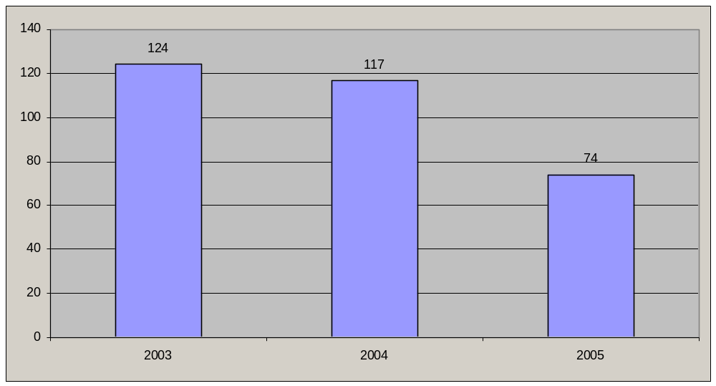Figure 1. Indicators of prosecutions of the offence of murder of children, arts. 115 and 116 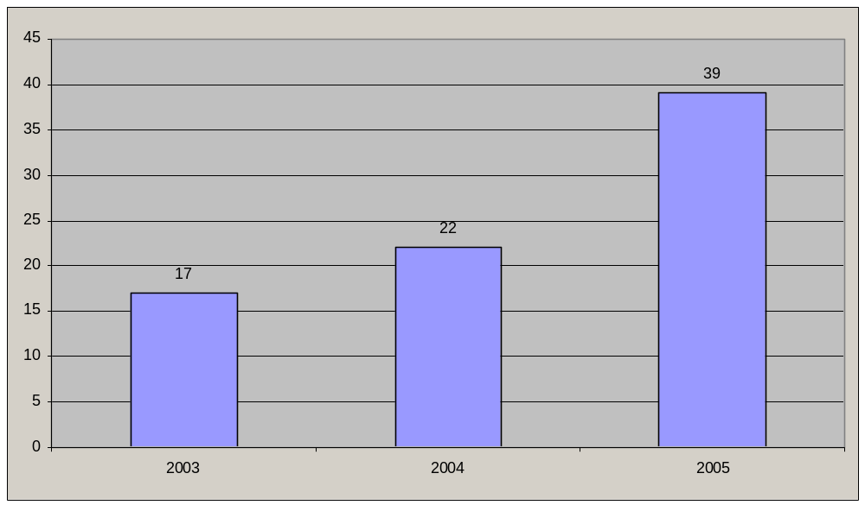Figure 2. Indicators of prosecutions of the offence of trafficking in children
and smuggling them across the State frontier, art. 149 (para. 2)

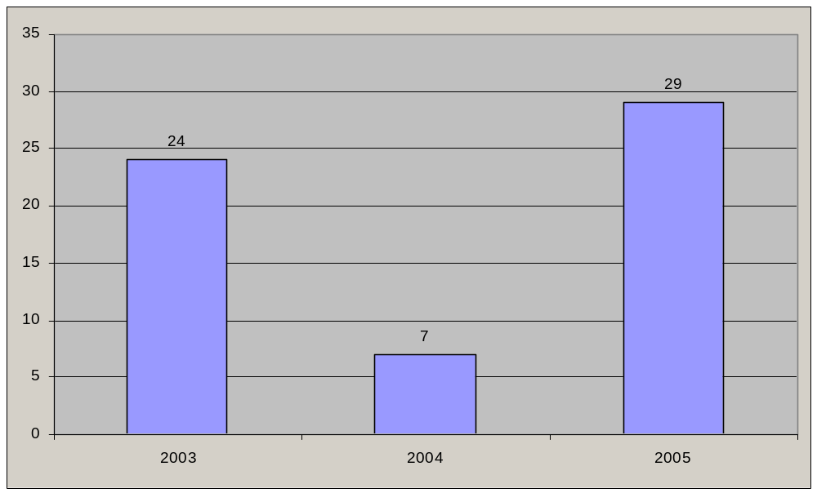 Figure 3. Indicators of prosecutions of the offence of exploitation of children, art. 150

Annex V

Information on crisis families and children being raised
in such families (based on information provided by the
Ministry for Family, Youth and Sport)
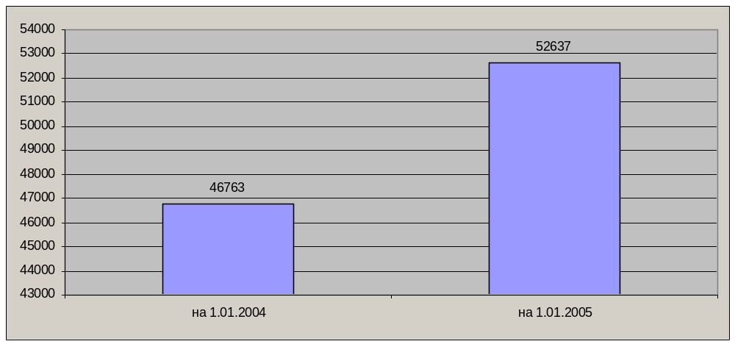Figure 6. Number of families in crisis situations, placed on the registers of the departments
for family and youth affairs, as on 1 January 2004 and 1 January 2005
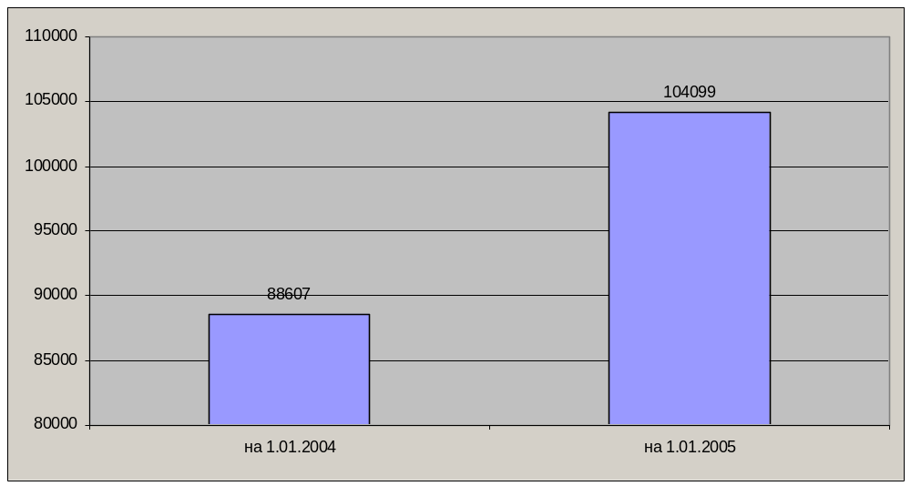 Figure 7. Number of children being raised in these families, as on
1 January 2004 and 1 January 2005
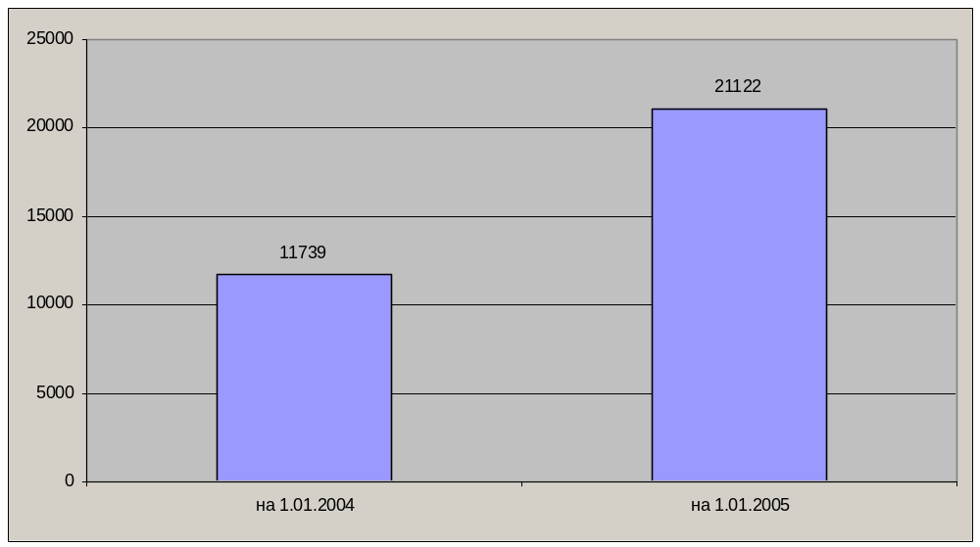Figure 8. Number of families on social welfare
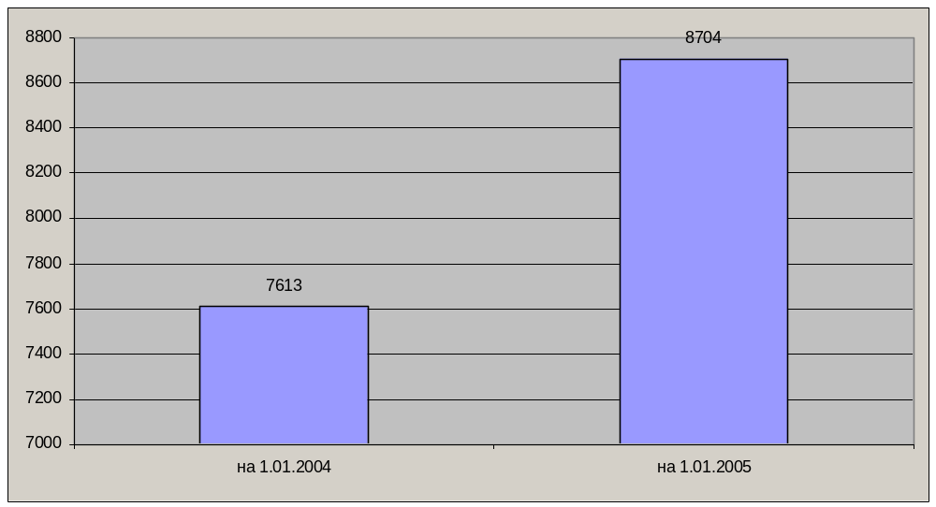Figure 9. Number of persons deprived of parental rights
(based on information from the courts)
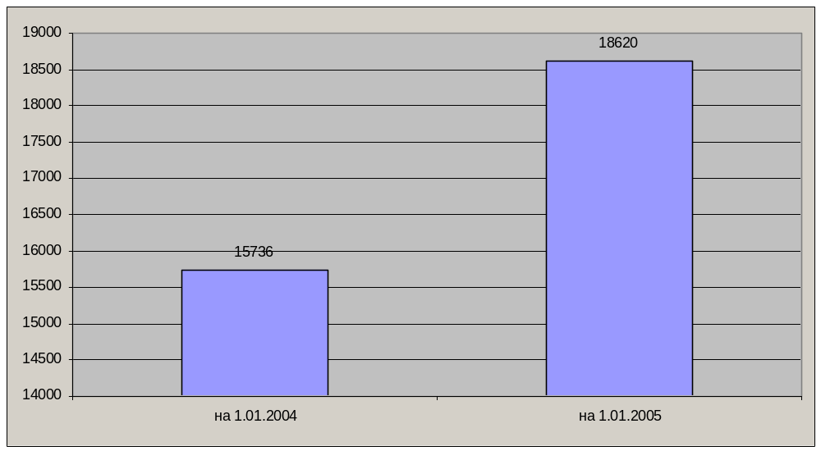Figure 10. Number of parents or persons acting in their stead prosecuted under
article 184 of the Ukrainian Code of Administrative Offences
- - - - -

* In accordance with the information transmitted to States parties regarding the processing of their reports, the present document was not formally edited before being sent to the United Nations translation services. GE.06-42567 (E) 030806 050906

